<https://explore.skillbuilder.aws/learn/course/134/play/31418/aws-cloud-practitioner-essentials-all-modules>

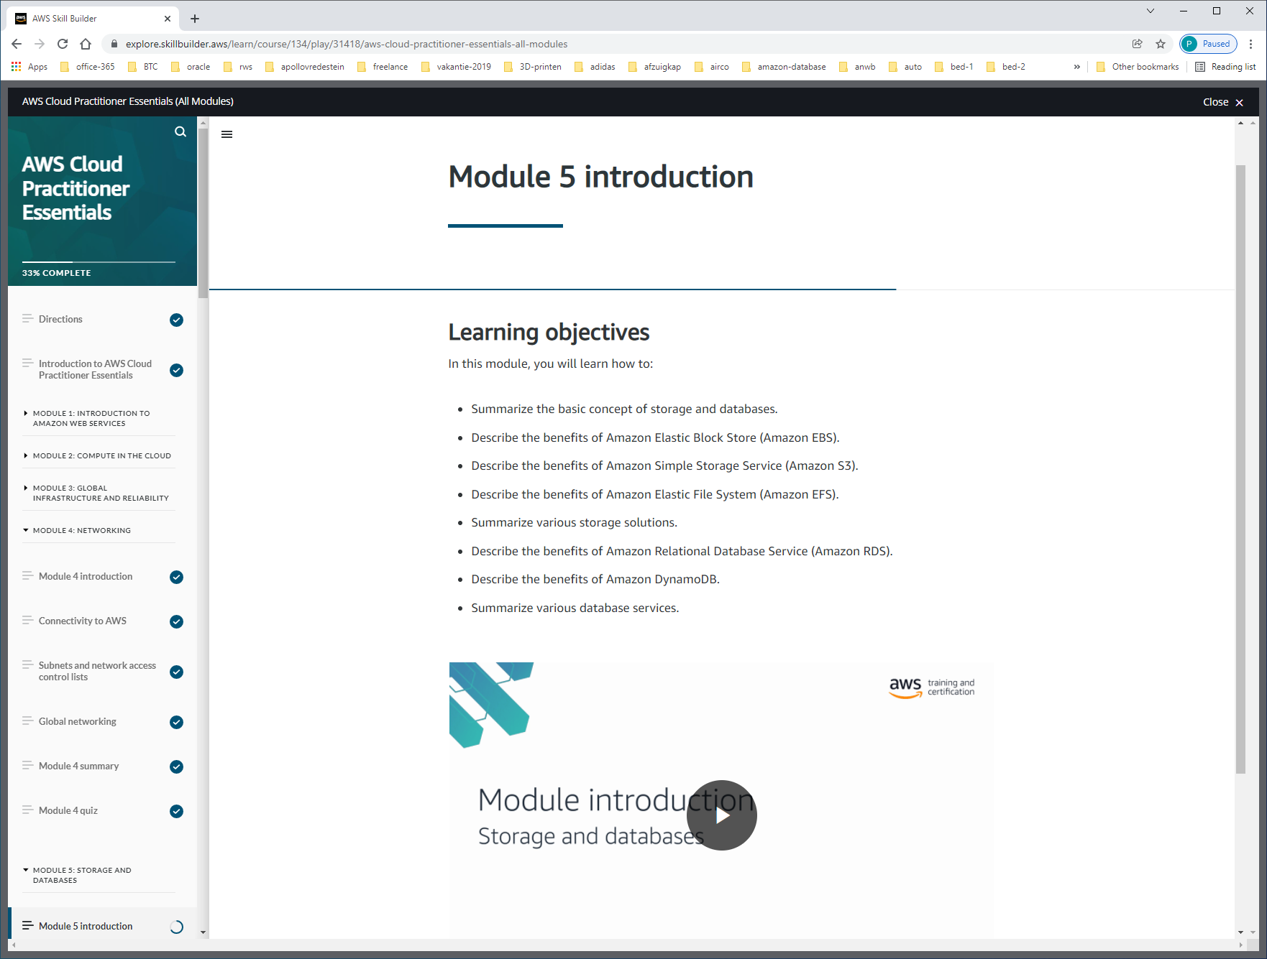

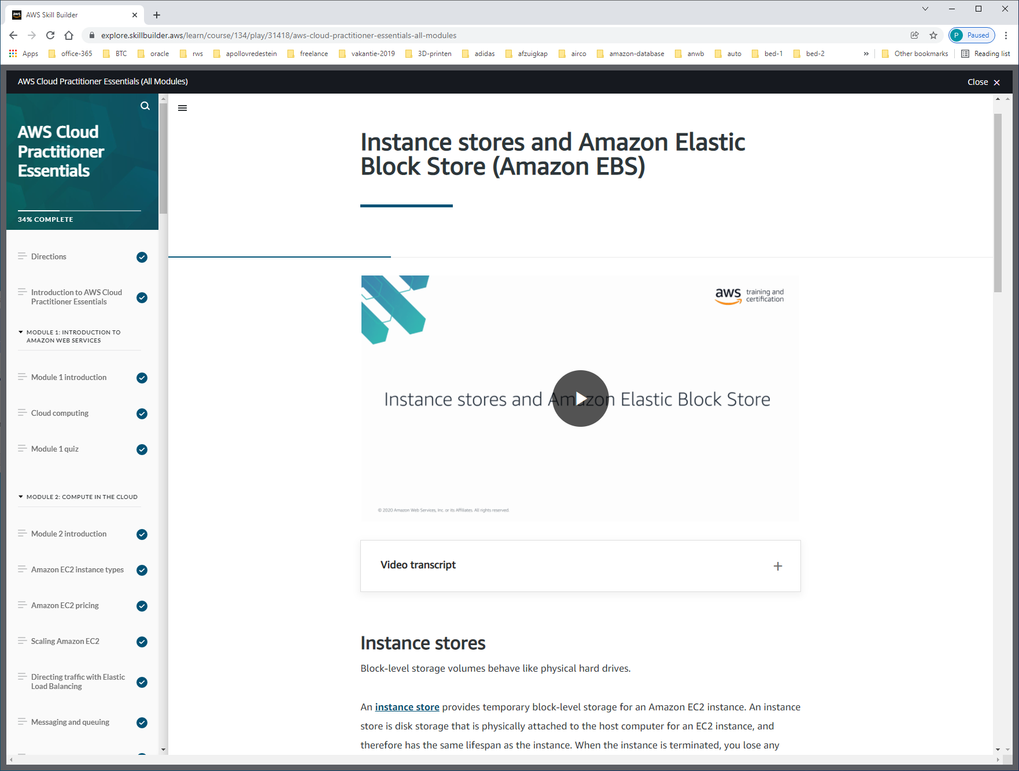

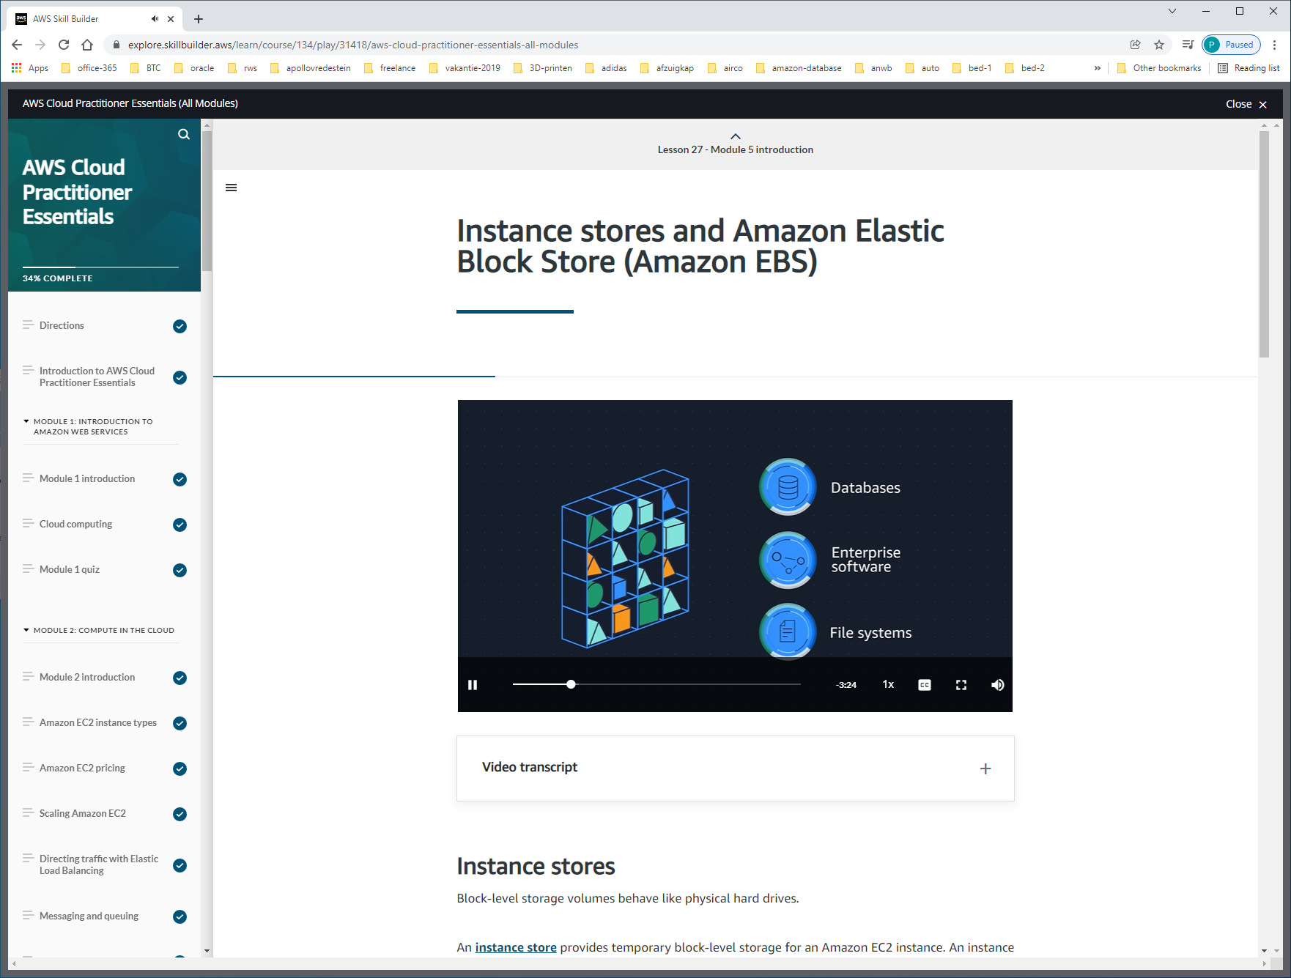

EC2-instances hebben ook hard-drives.   
LOCAL-STORAGE = INSTANCE-STORE-VOLUMES, fysiek aan instance. Als je instance stopt ben je ook data kwijt. Dat komt omdat als je instance start, dan kan deze op een fysiek andere host gestart worden. EC2-instances zijn VM's.

Dit is dus alleen bedoeld voor TEMP-files, scratch-data.

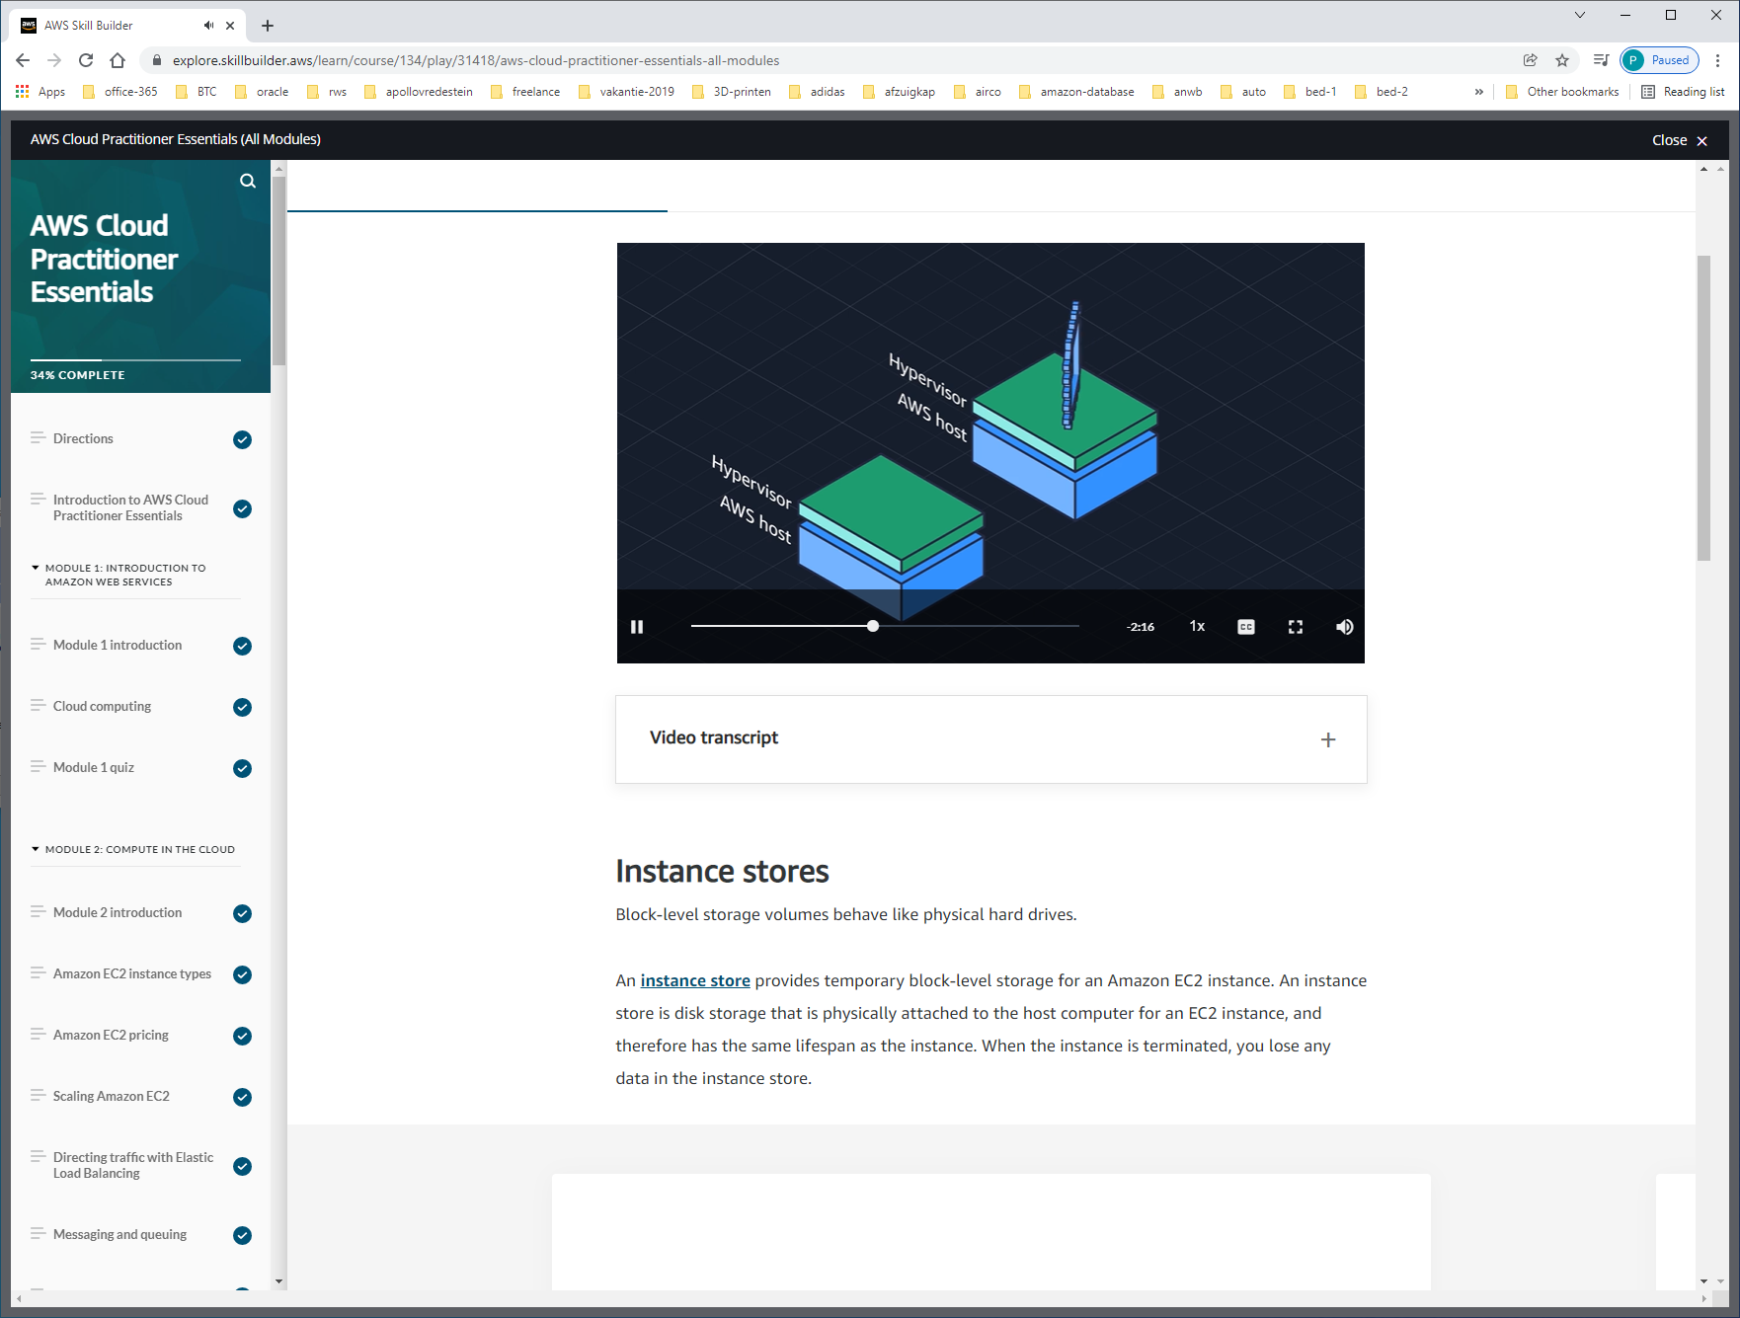

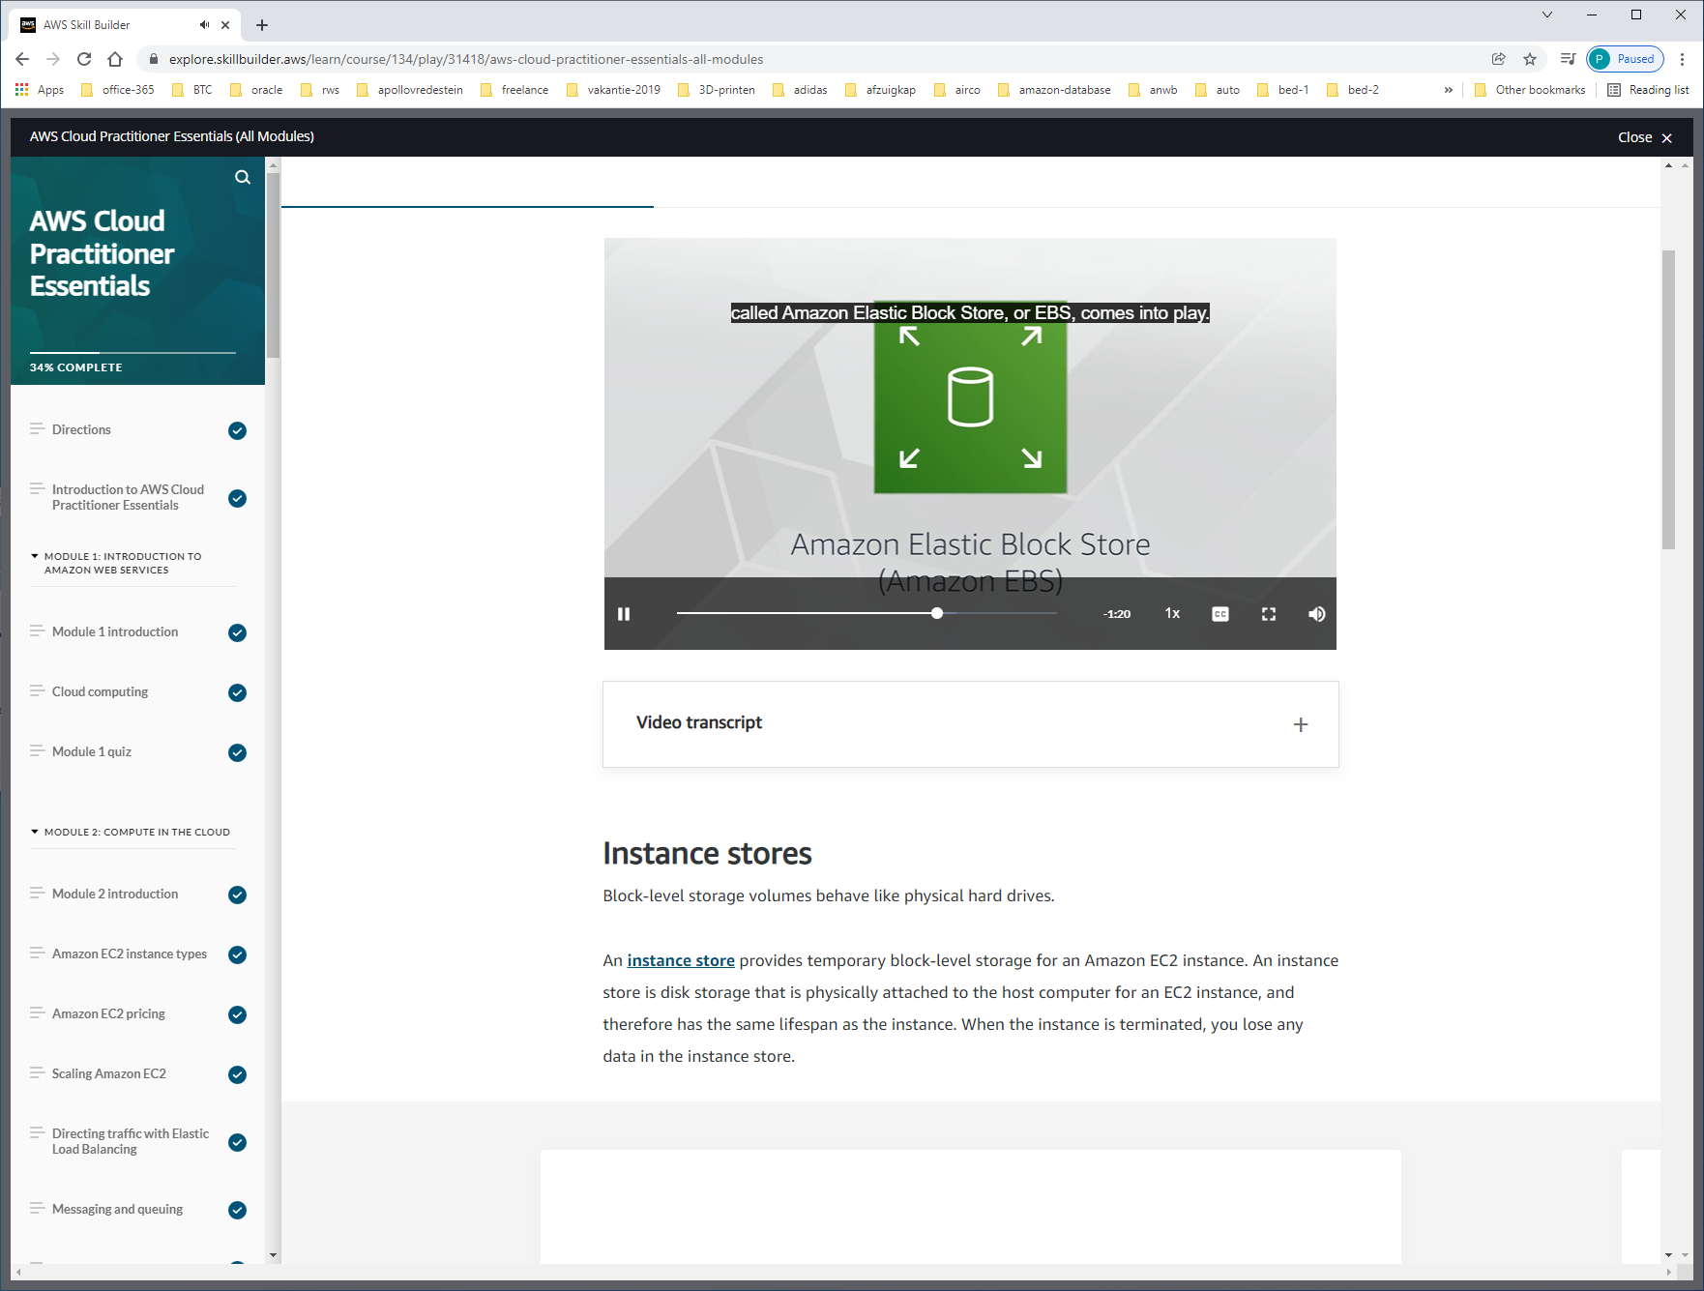

EBS-volumes die je aan EC2-instance kunt koppelen. Data op deze volumes is persistant.

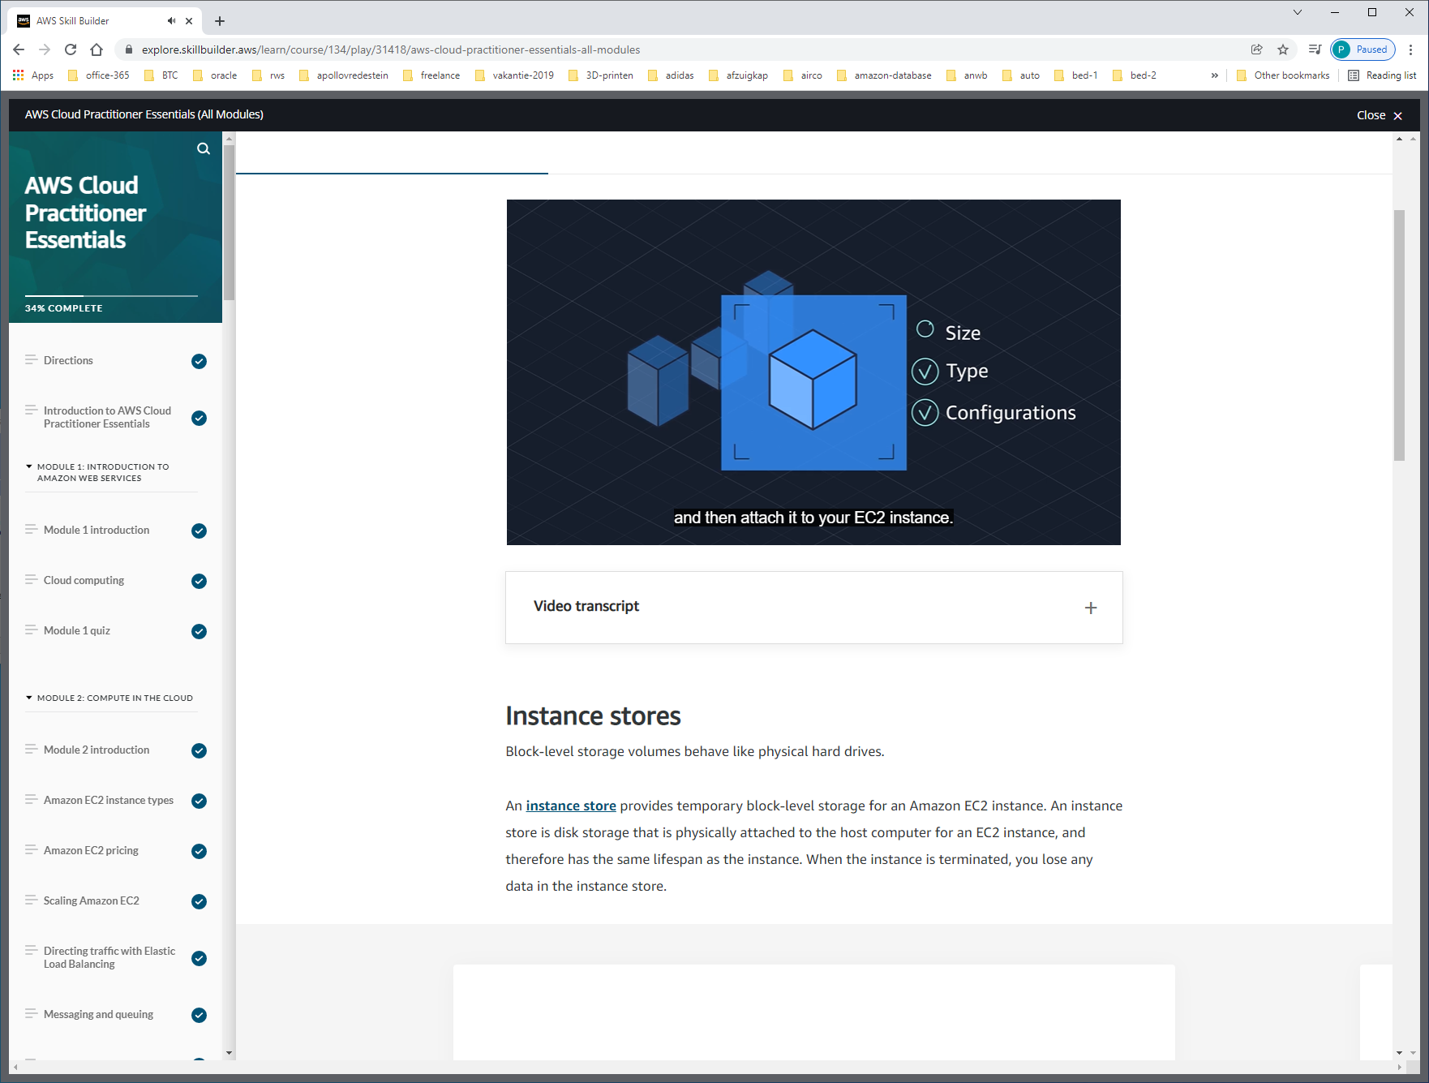

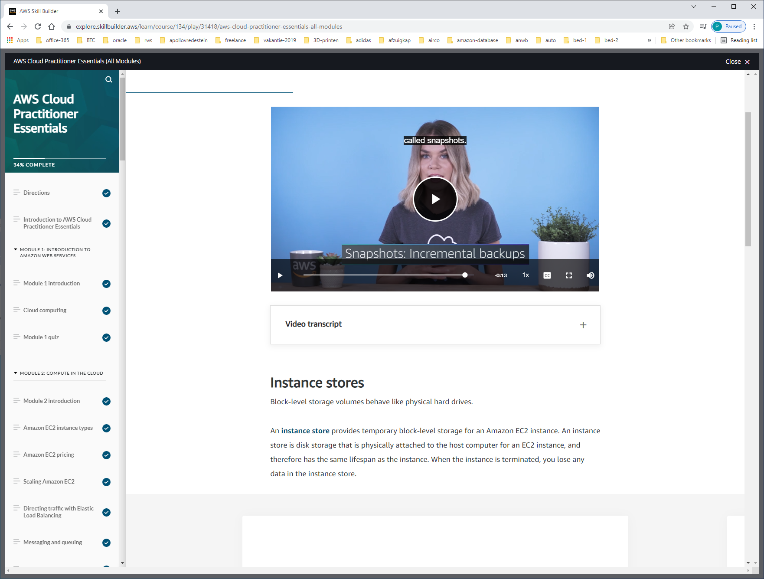

Maak incremental-backups voor geval hard-disk crashed = snapshot.

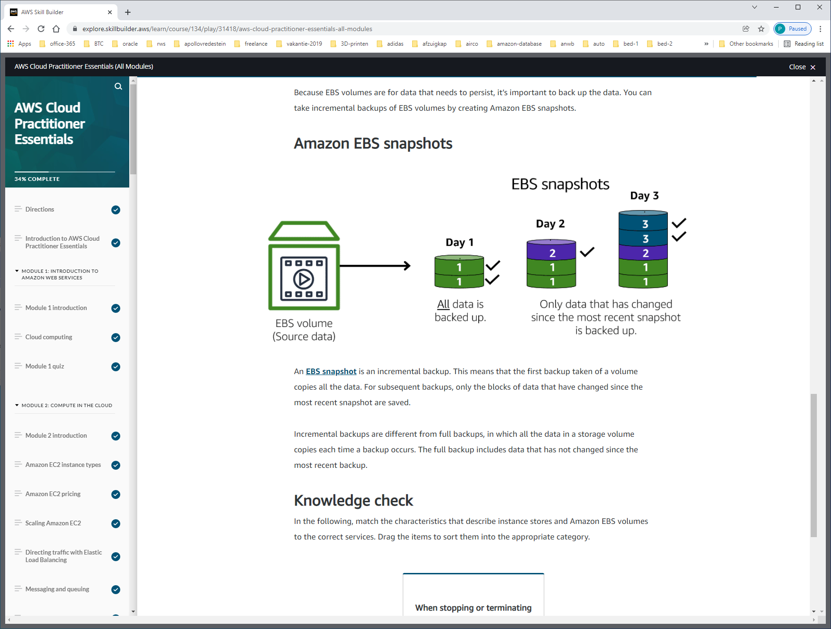

An [**EBS snapshot**](https://docs.aws.amazon.com/AWSEC2/latest/UserGuide/EBSSnapshots.html) is an incremental backup. This means that the first backup taken of a volume copies all the data. For subsequent backups, only the blocks of data that have changed since the most recent snapshot are saved.

Incremental backups are different from full backups, in which all the data in a storage volume copies each time a backup occurs. The full backup includes data that has not changed since the most recent backup.

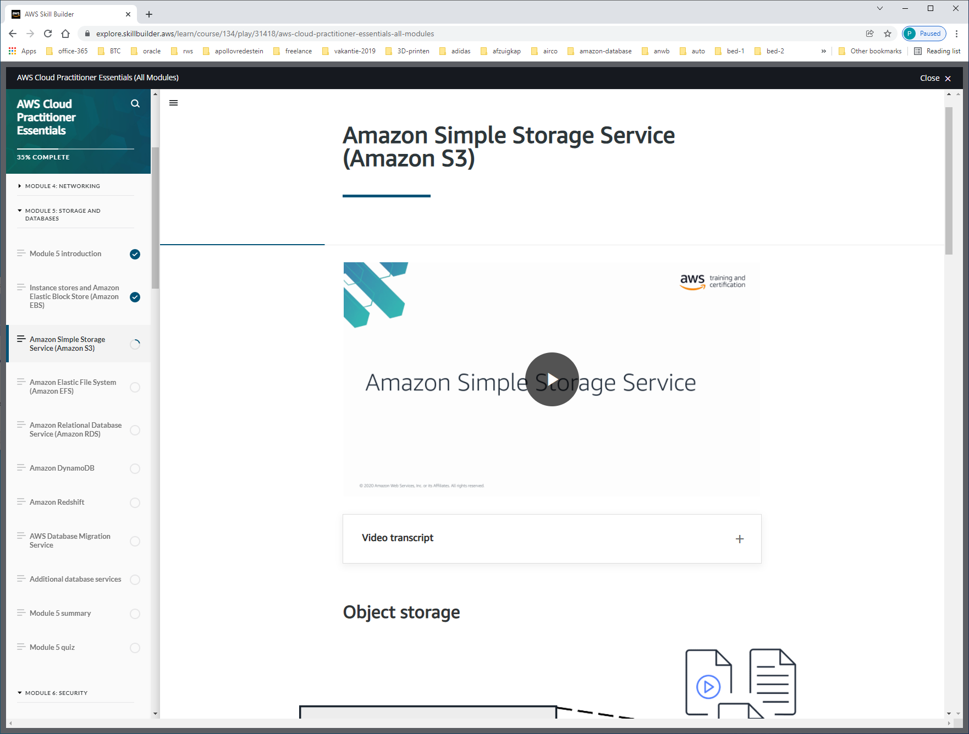

DATA-STORE to store/retrieve data as objects in a file-directory (=buckets).

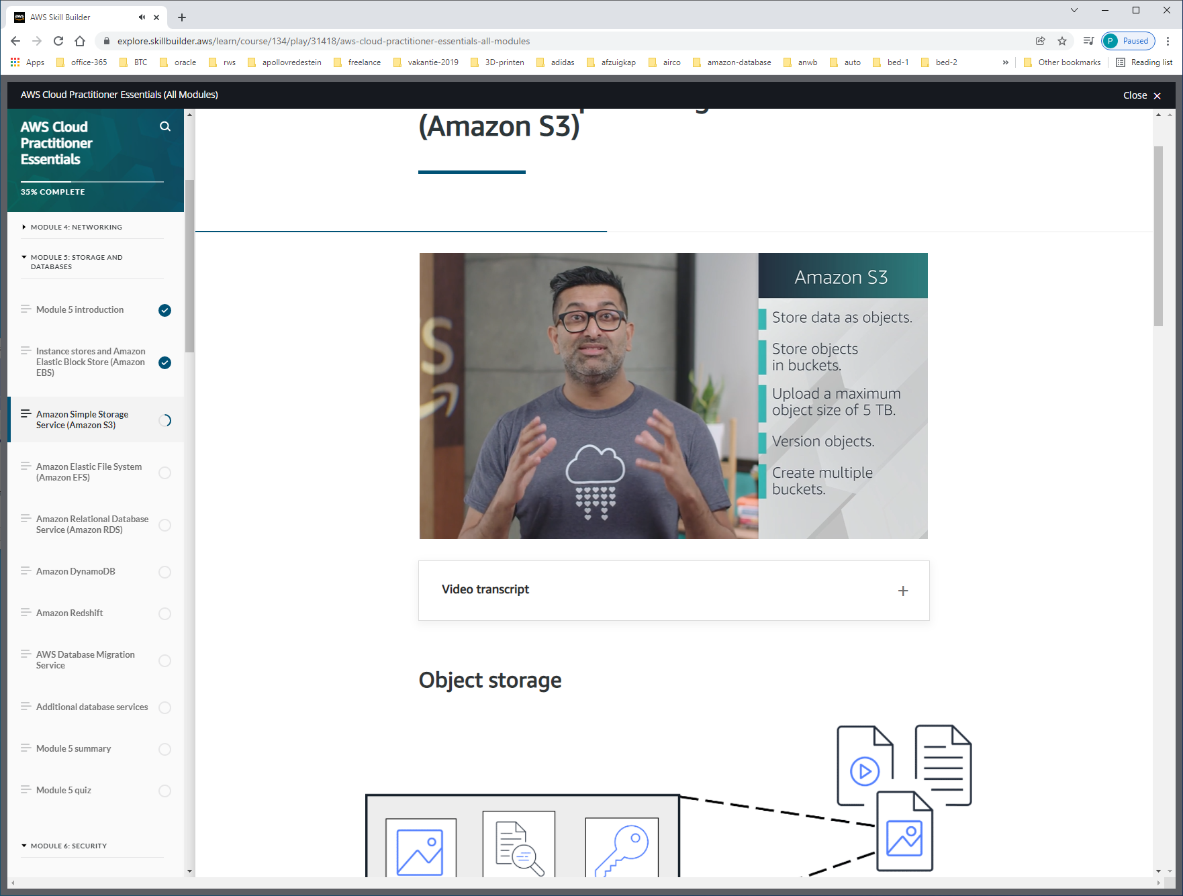

With Amazon S3, you pay only for what you use. You can choose from [a range of storage classes](https://aws.amazon.com/s3/storage-classes) to select a fit for your business and cost needs. When selecting an Amazon S3 storage class, consider these two factors:

* How often you plan to retrieve your data
* How available you need your data to be

AMAZON S3 STANDARD

* Designed for frequently accessed data
* Stores data in a minimum of three Availability Zones

S3 Standard provides high availability for objects. This makes it a good choice for a wide range of use cases, such as websites, content distribution, and data analytics. S3 Standard has a higher cost than other storage classes intended for infrequently accessed data and archival storage.

AMAZON S3-STANDARD-IA (infrequent access)

* Ideal for infrequently accessed data
* Similar to S3 Standard but has a lower storage price and higher retrieval price

S3 Standard-IA is ideal for data infrequently accessed but requires high availability when needed. Both S3 Standard and S3 Standard-IA store data in a minimum of three Availability Zones. S3 Standard-IA provides the same level of availability as S3 Standard but with a lower storage price and a higher retrieval price.

AMAZON ONE-ZONE-IA (Infrequent ACCESS)

* Stores data in a single Availability Zone
* Has a lower storage price than S3 Standard-IA

Compared to S3 Standard and S3 Standard-IA, which store data in a minimum of three Availability Zones, S3 One Zone-IA stores data in a single Availability Zone. This makes it a good storage class to consider if the following conditions apply:

* You want to save costs on storage.
* You can easily reproduce your data in the event of an Availability Zone failure.

AMAZON S3 INTELLIGENT-TIERING

* Ideal for data with unknown or changing access patterns
* Requires a small monthly monitoring and automation fee per object

In the S3 Intelligent-Tiering storage class, Amazon S3 monitors objects’ access patterns. If you haven’t accessed an object for 30 consecutive days, Amazon S3 automatically moves it to the infrequent access tier, S3 Standard-IA. If you access an object in the infrequent access tier, Amazon S3 automatically moves it to the frequent access tier, S3 Standard.

AMAZON S3-GLACIER

* Low-cost storage designed for data archiving
* Able to retrieve objects within a few minutes to hours

S3 Glacier is a low-cost storage class that is ideal for data archiving. For example, you might use this storage class to store archived customer records or older photos and video files.

AMAZON S3-GLACIER-DEEP-ARCHIVE

* Lowest-cost object storage class ideal for archiving
* Able to retrieve objects within 12 hours

When deciding between Amazon S3 Glacier and Amazon S3 Glacier Deep Archive, consider how quickly you need to retrieve archived objects. You can retrieve objects stored in the S3 Glacier storage class within a few minutes to a few hours. By comparison, you can retrieve objects stored in the S3 Glacier Deep Archive storage class within 12 hours.

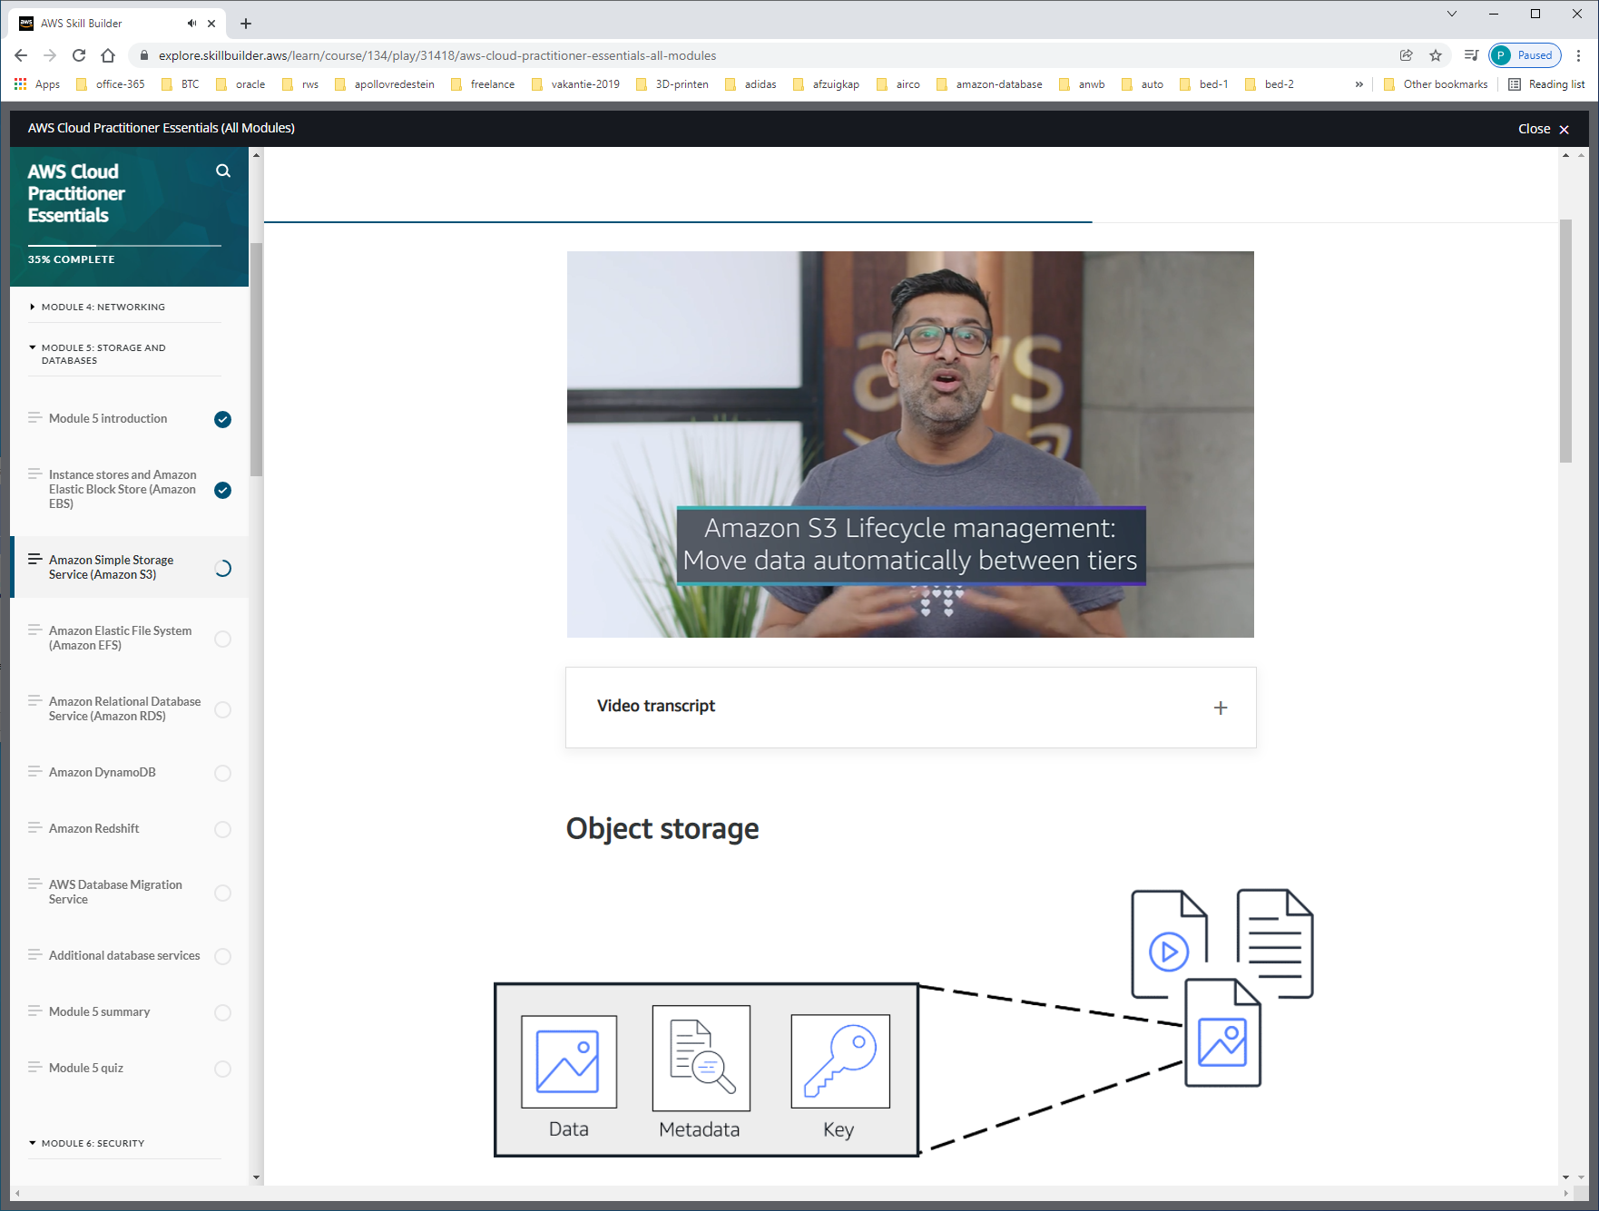

Met lifecycle-policies kun je vantevoren aangeven na hoeveel dagen de files van STORAGE kunnen wisslen.

Het is zelfs mogelijk om storage te locken, zodat data niet meer gewijzigd kan worden WORM=write-once-read-many.

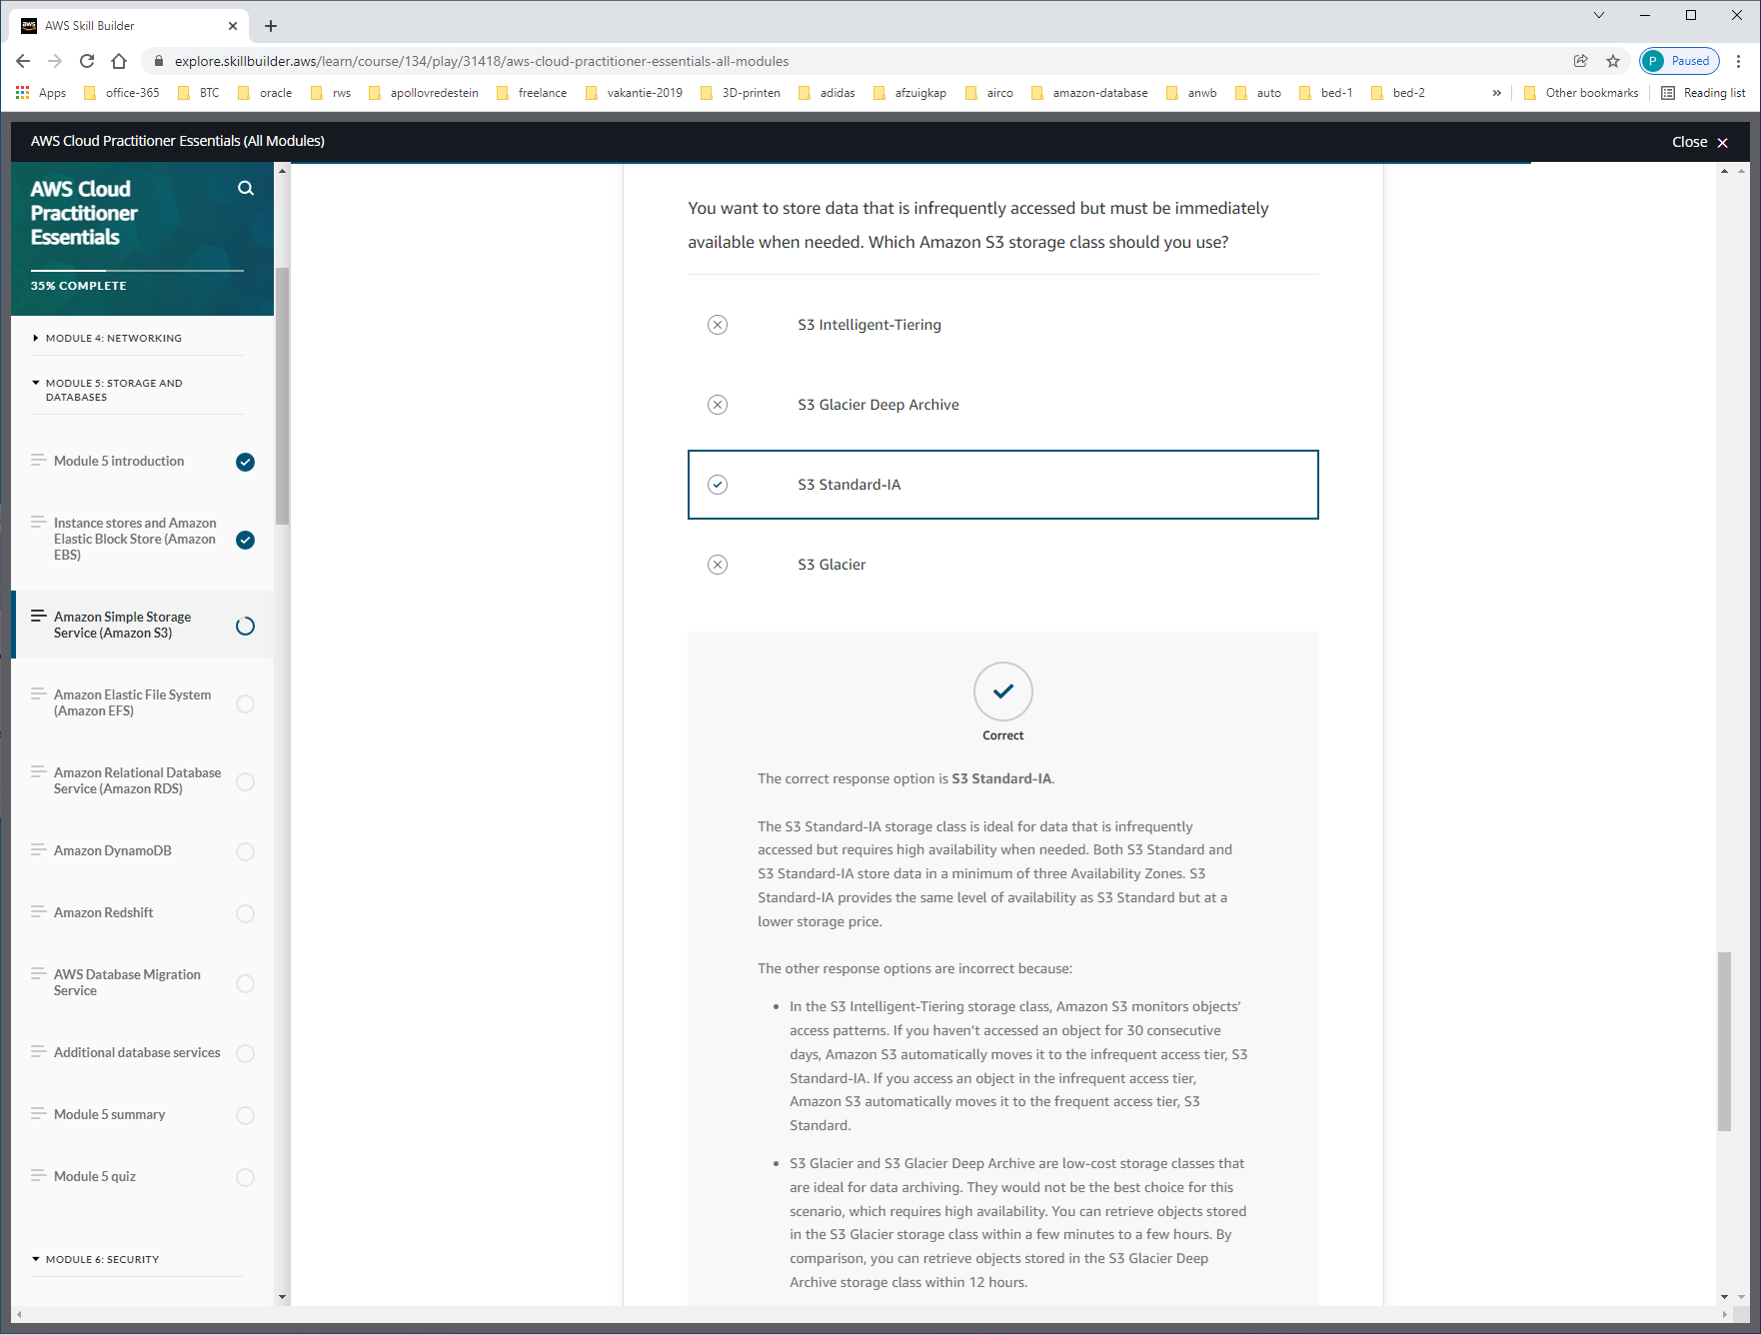

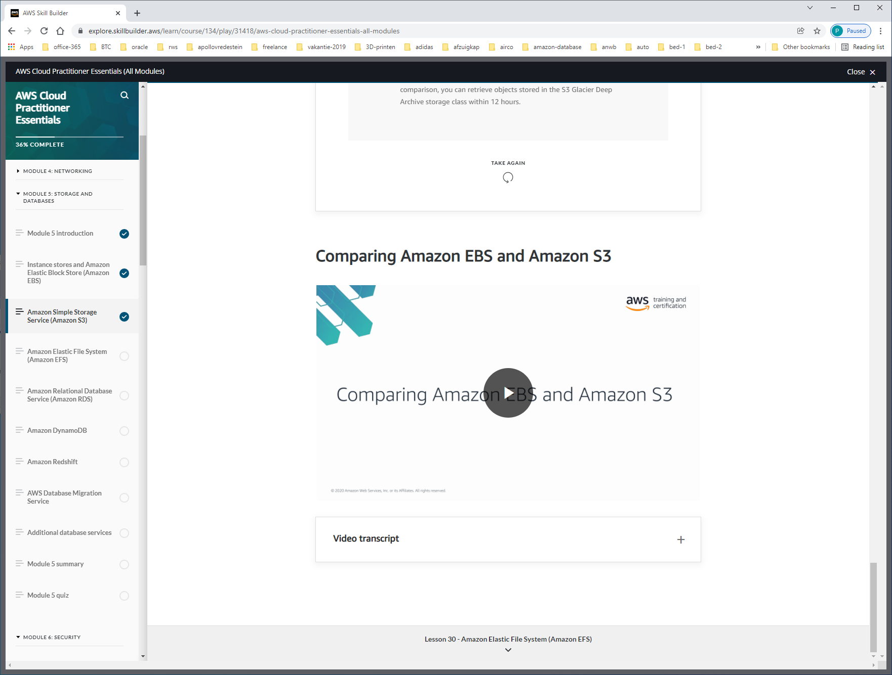

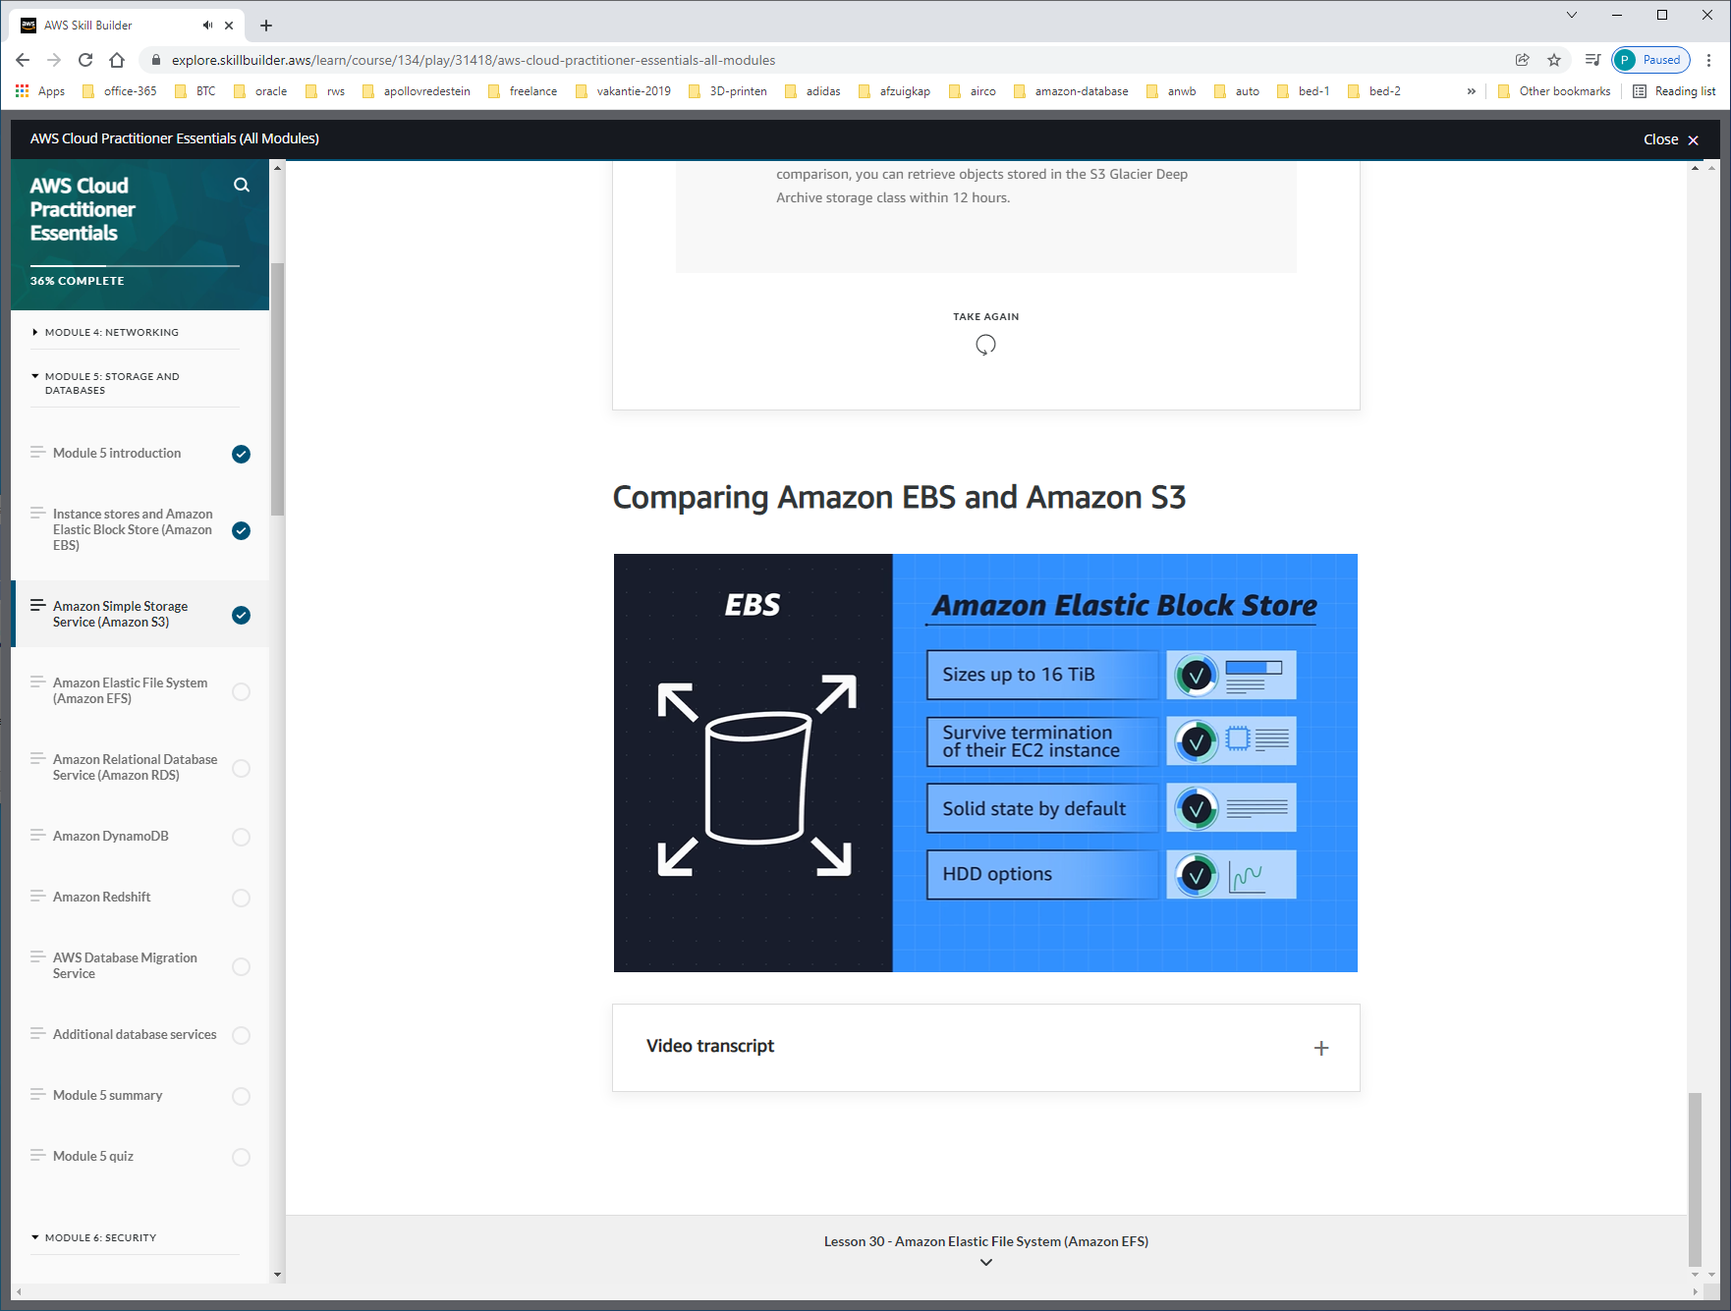

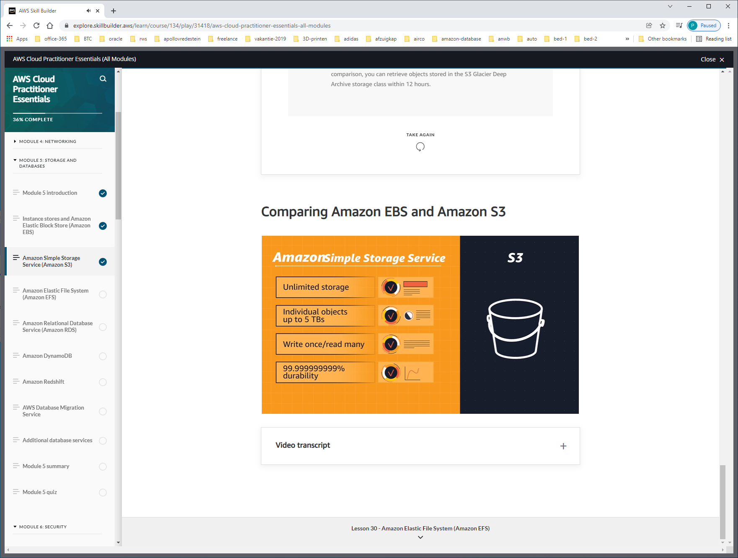

Je hebt miljoenen foto's die geraadpleegd moeten worden:

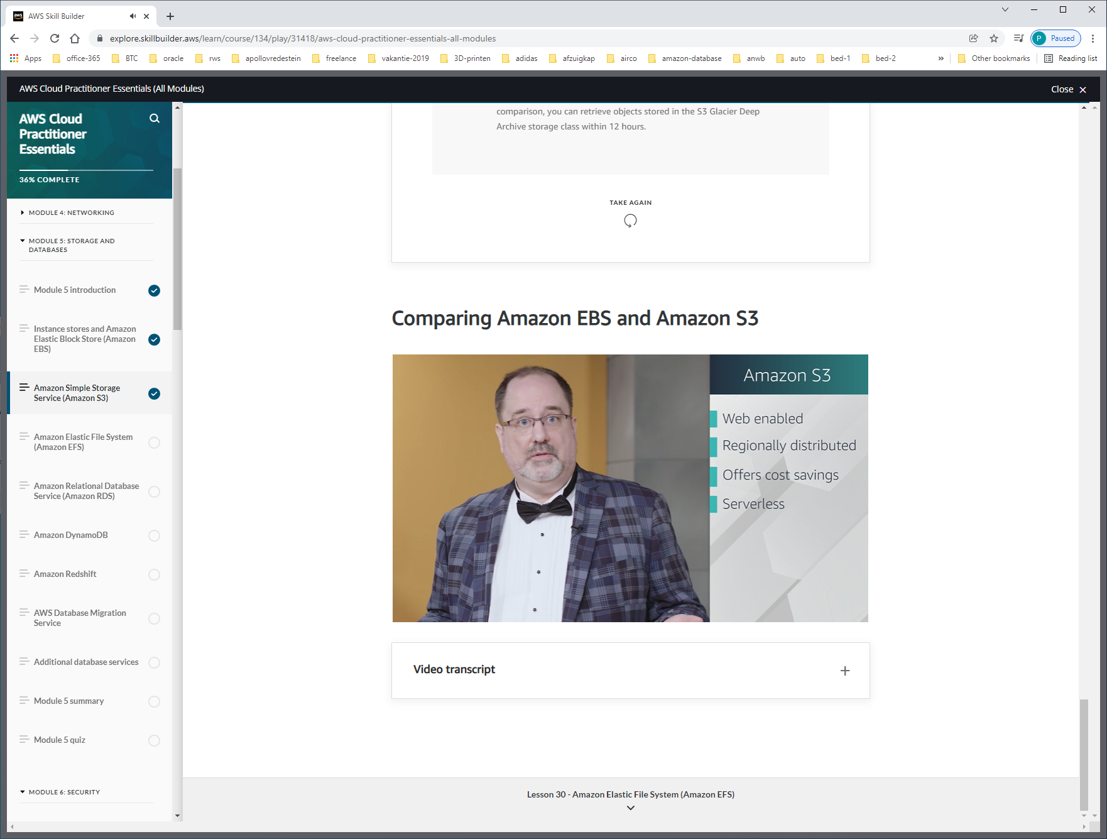

Bestanden zijn web-enabled, zijn al direct met een URL te benaderen.

Als een bestand wijzigt moet het hele bestand opnieuw gesaved worden, er zijn geen updates.

80GB video-file. Als je maar 1 gedeelte wijzigt. Dan is block-storage beter. Dan hoeft alleen maar 1 block geupdate te worden.

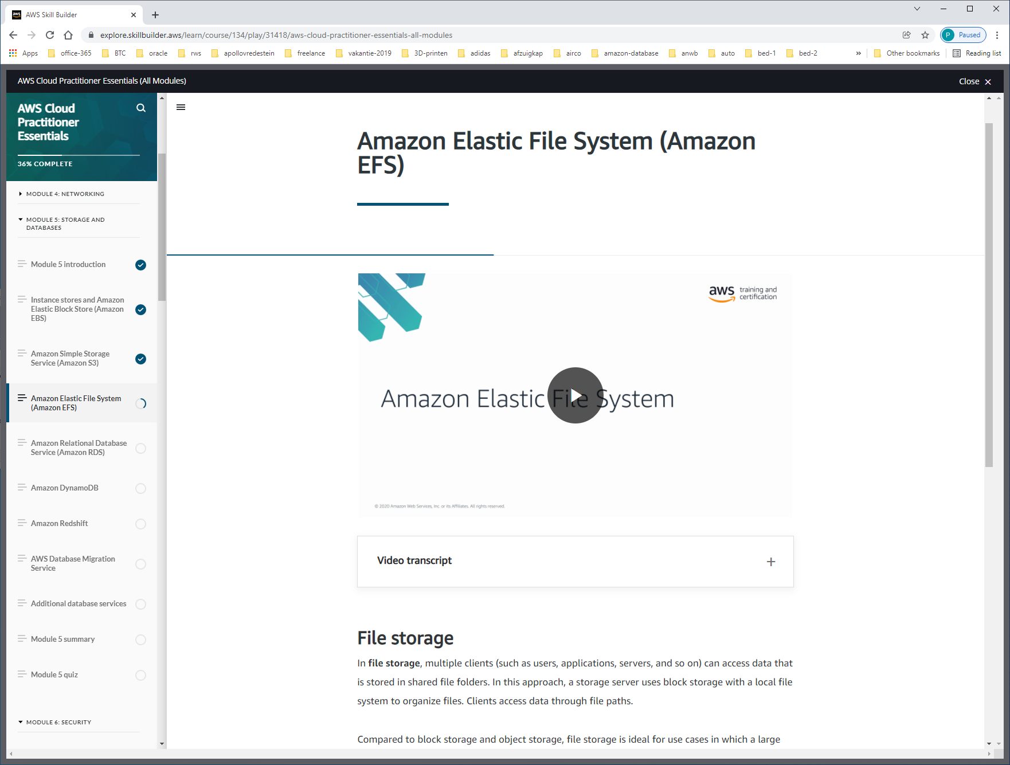

EFS = shared file system.

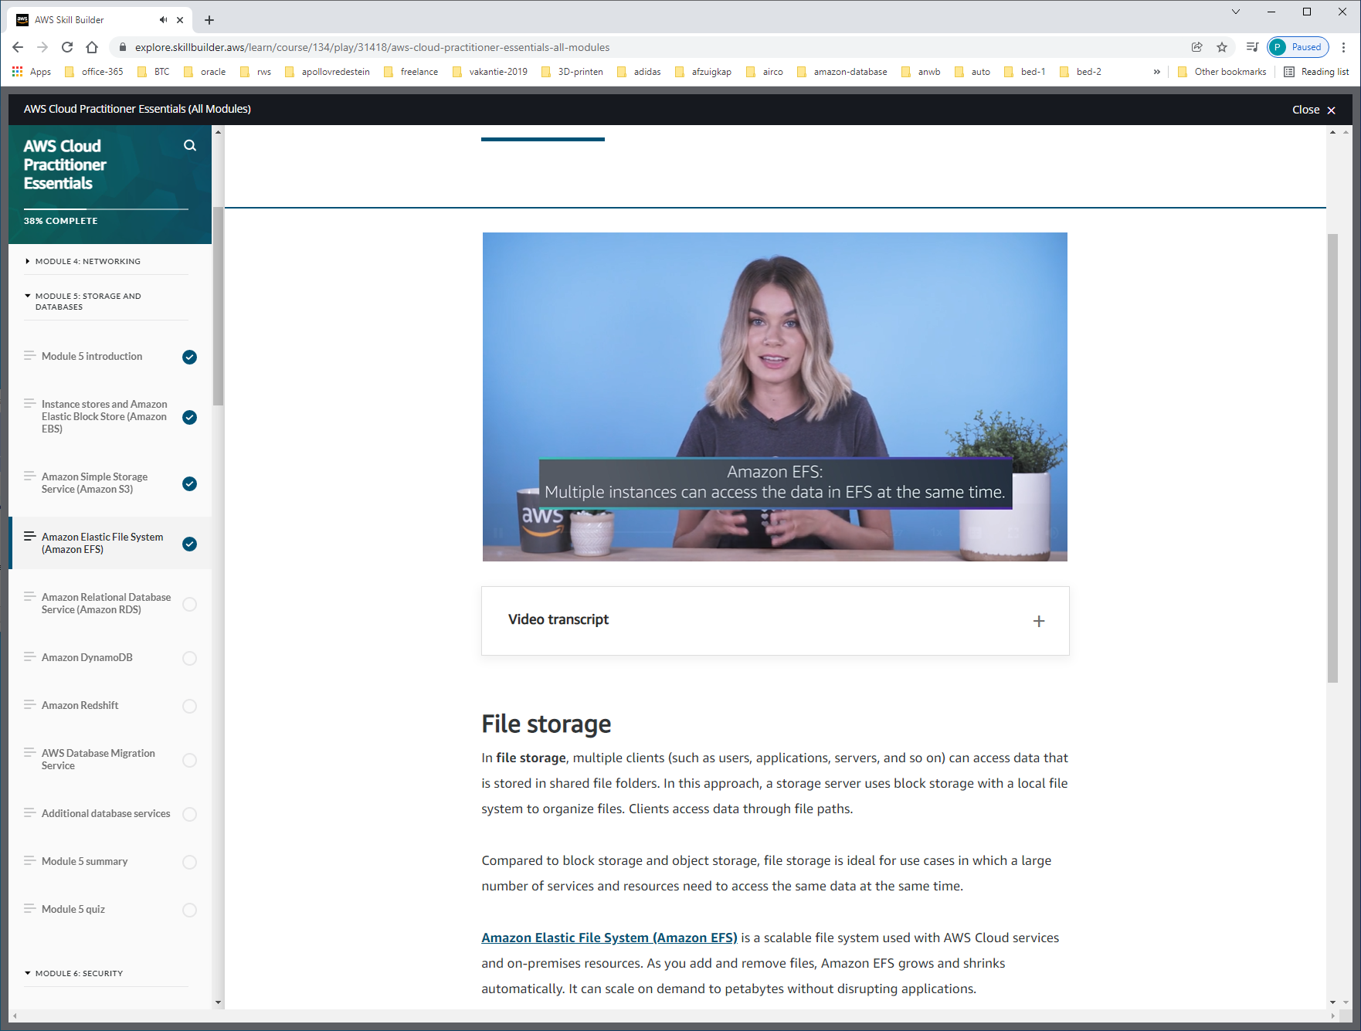

EBS =

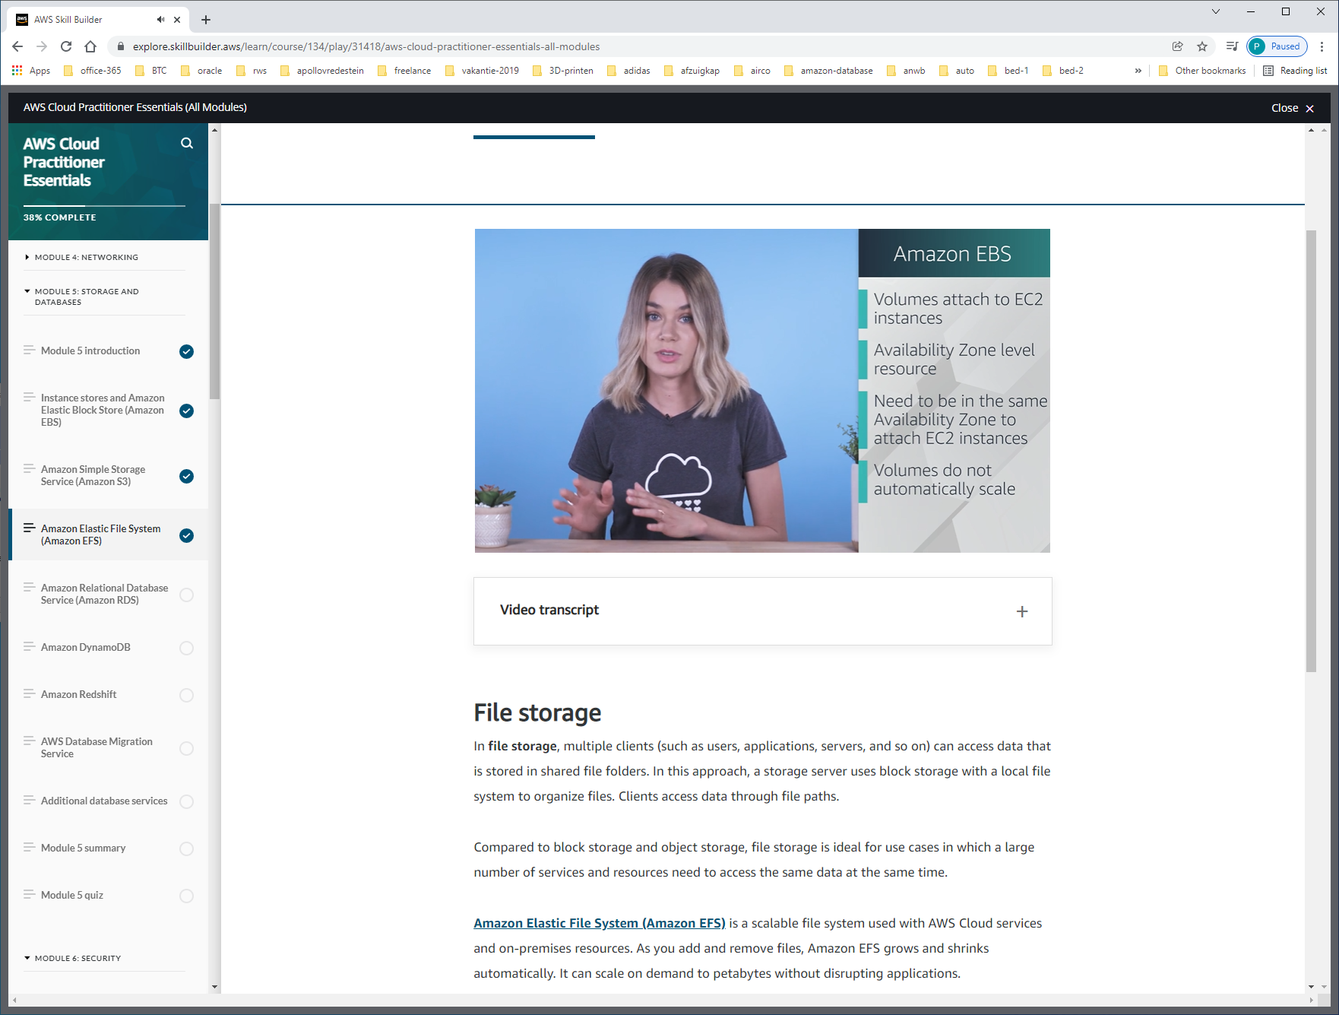

EFS

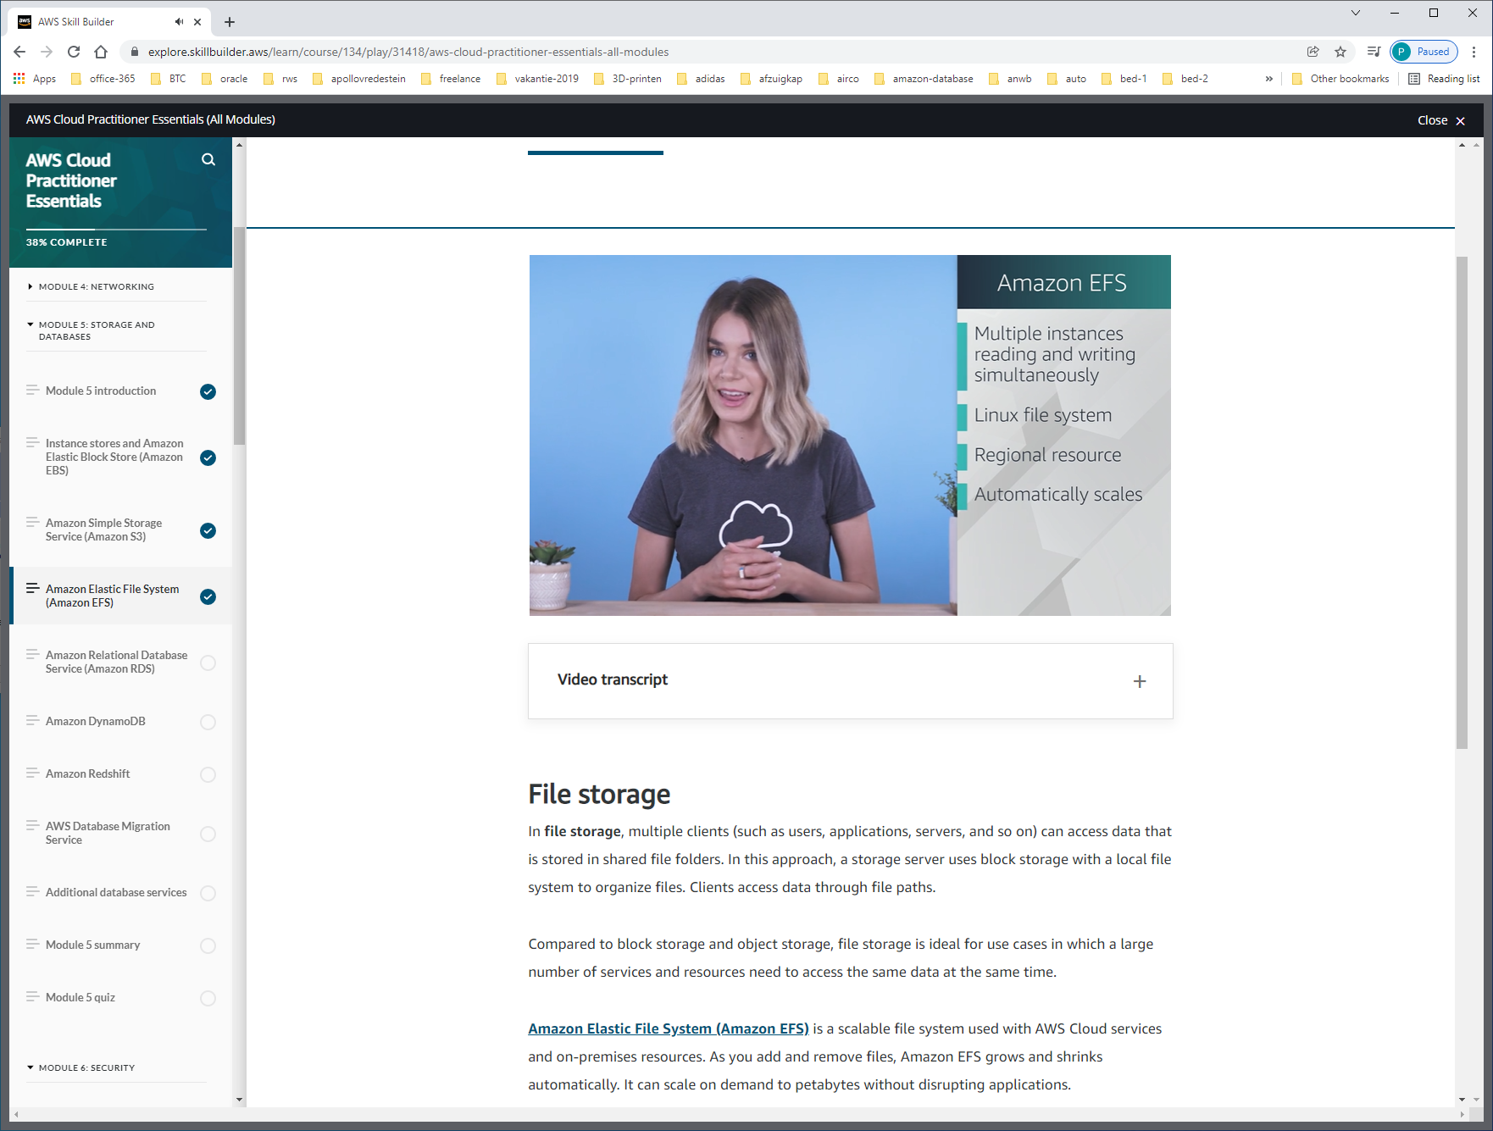

[**Amazon Elastic File System (Amazon EFS)**](https://aws.amazon.com/efs/) is a scalable file system used with AWS Cloud services and on-premises resources. As you add and remove files, Amazon EFS grows and shrinks automatically. It can scale on demand to petabytes without disrupting applications.

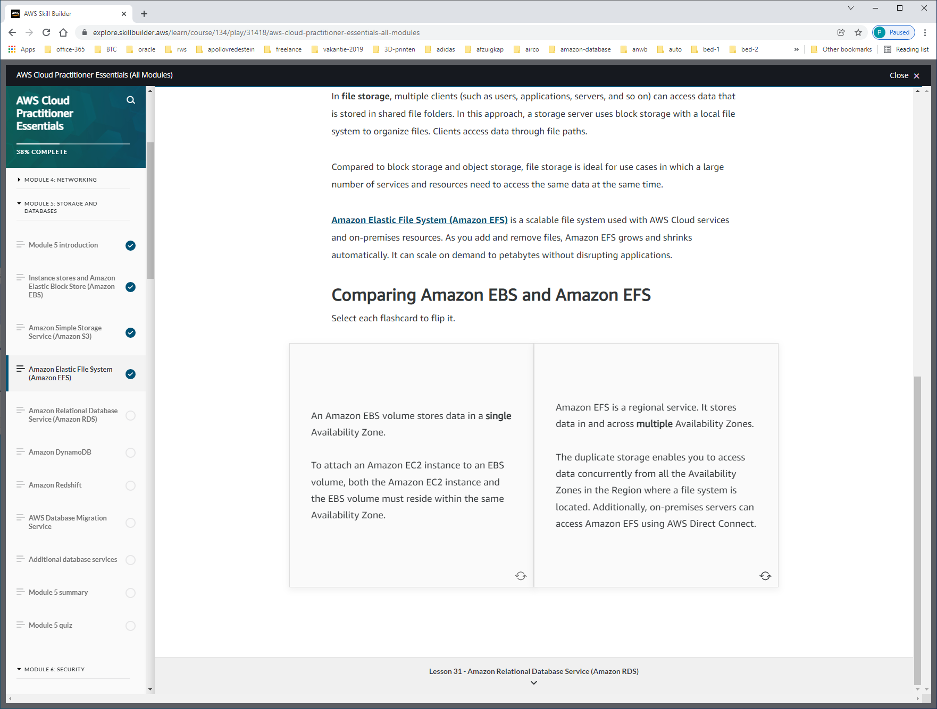

Dus:  
EBS DATA in a single-AZ, EC2-instance + EBS within same AZ  
EFS A REGIONAL-service, multiple AZ's, also on-premise-servers can access EFS using AWS direct-connect.

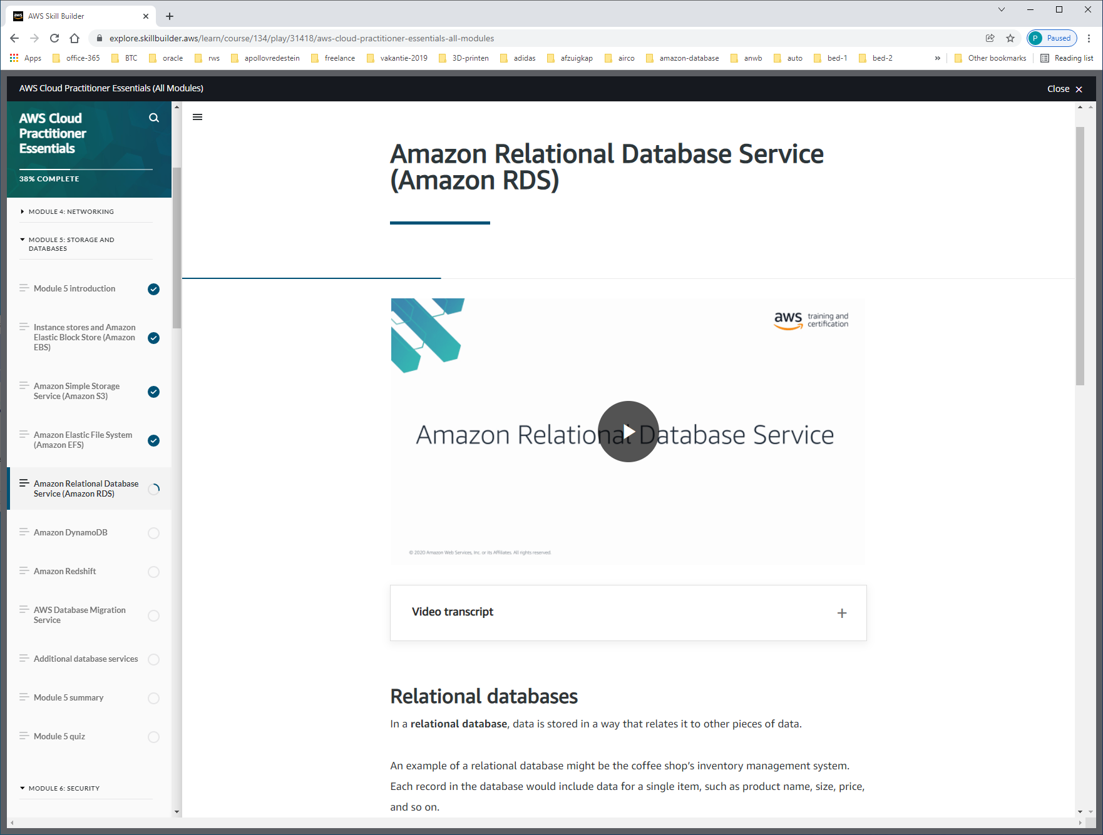

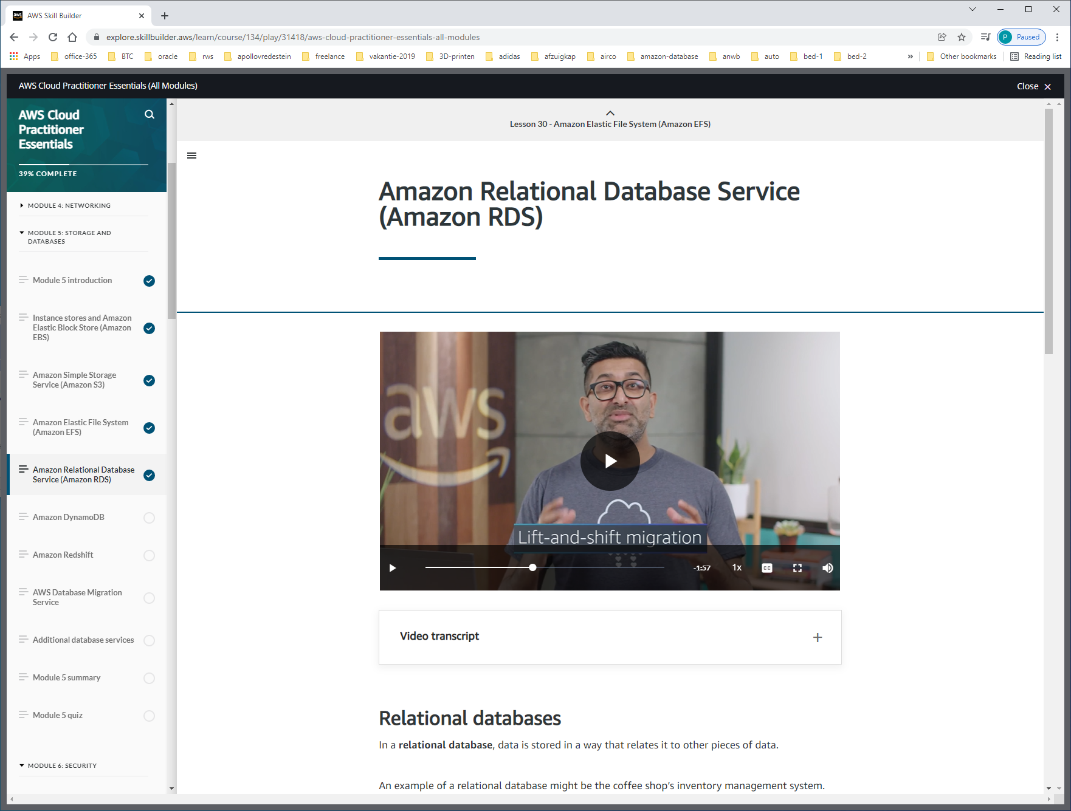

Lift-and-shift-migration om on-premise db te migreren naar de cloud.

Amazon RDS is available on six database engines, which optimize for memory, performance, or input/output (I/O). Supported database engines include:

* Amazon Aurora
* PostgreSQL
* MySQL
* MariaDB
* Oracle Database
* Microsoft SQL Server

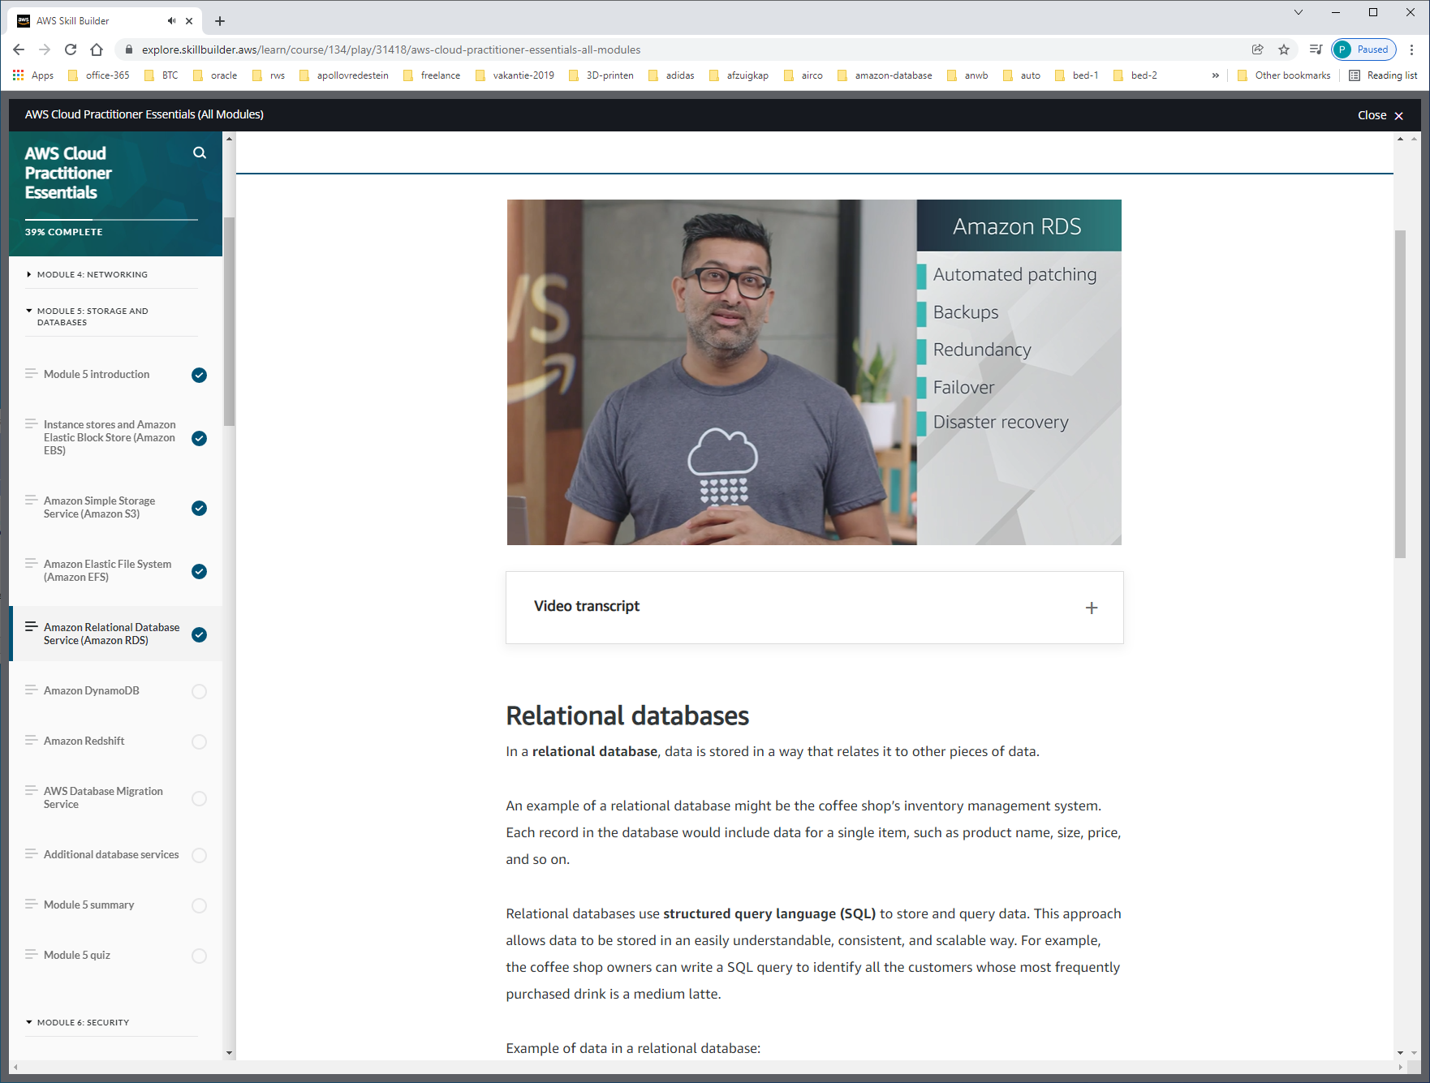

Andere opties:

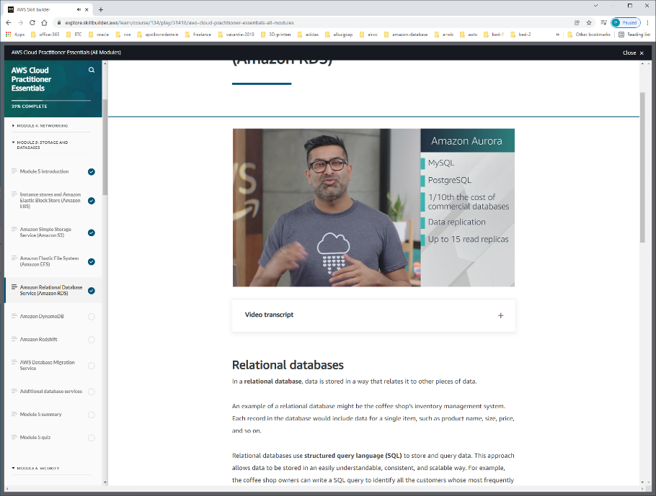

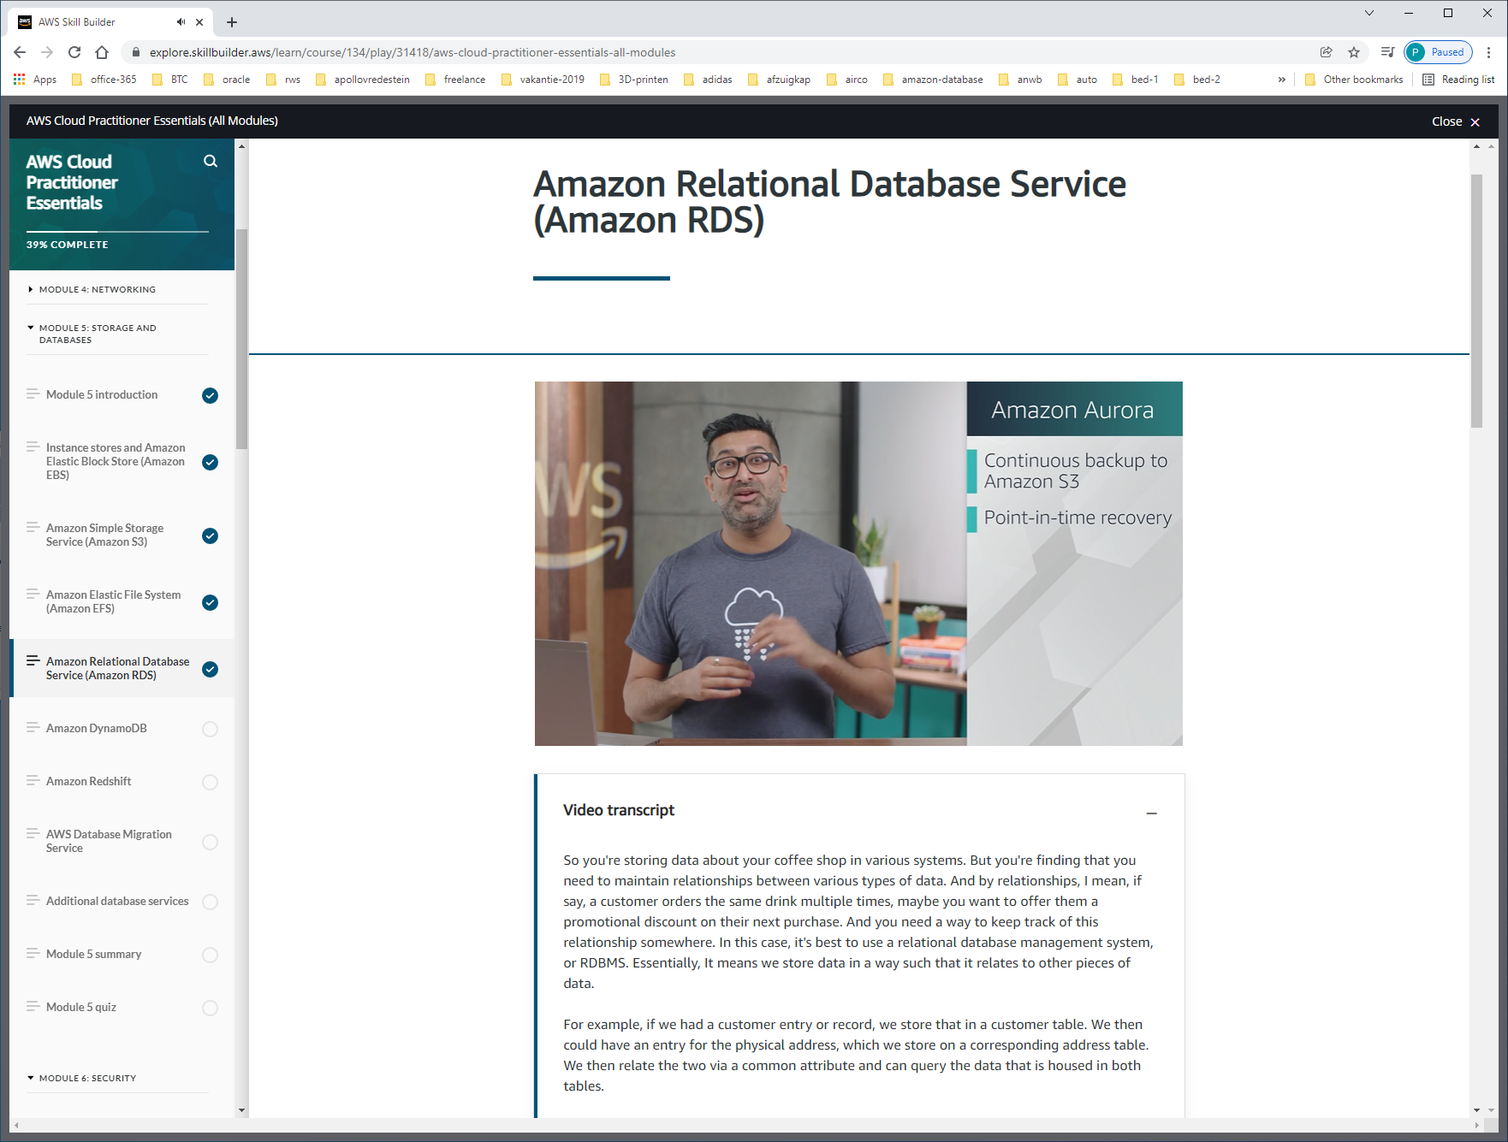

 It comes in two forms, MySQL and PostgreSQL.   
And is priced is 1/10th the cost of commercial grade databases. That's a pretty cost effective database.   
The other benefits are things like your data is replicated across facilities, so you have six copies at any given time.   
You can also deploy up to 15 read replicas, so you can offload your reads and scale performance.   
Additionally, there's continuous backups to S3, so you always have a backup ready to restore. You also get point in time recovery, so you can recover data from a specific period.

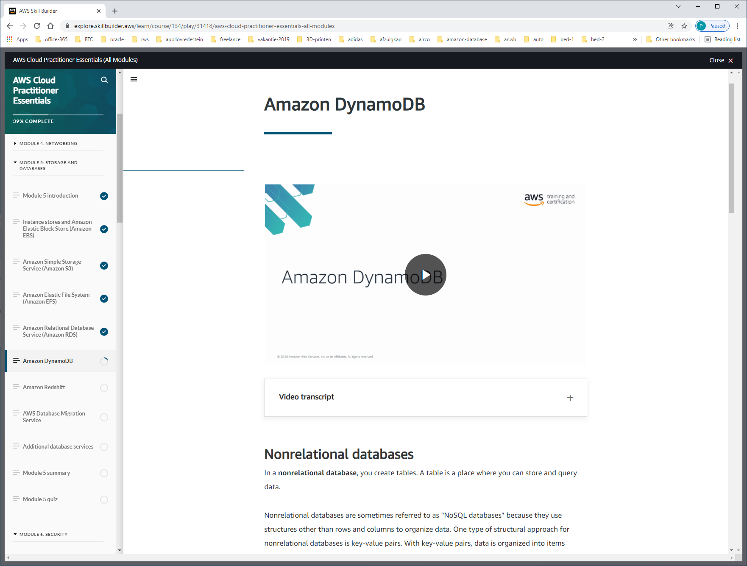

AMAZON-DYNAMO-DB = NoSQL = Non-Relational.

-serverless (you don't have to provision, patch or manage servers)

-auto-scaling automatically scales while maintaining consistent performance

-storage redundancy over AZ under-the-hood.

-milli-sec responsetime

-niet iedere tabel-record hoeft dezelfde attributen te hebben.

-queries zijn gefocussed op 1 object en niet als normale sql over meerdere rijen.

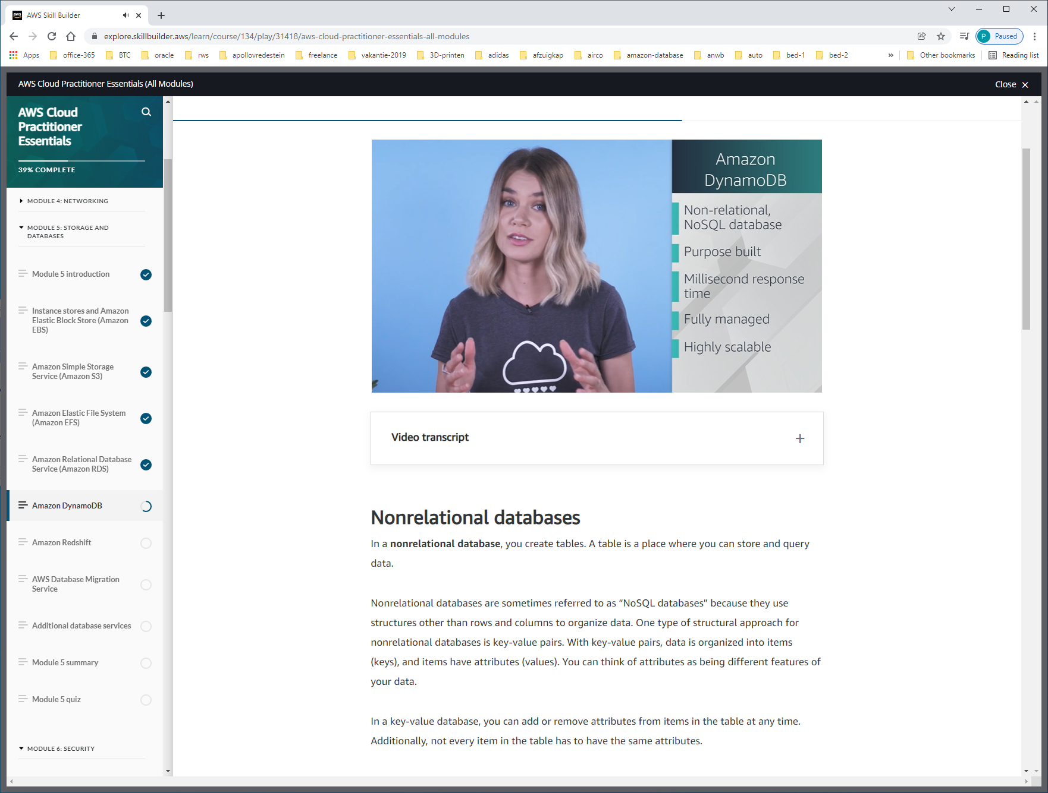

Compare RDS – DYNAMO-DB

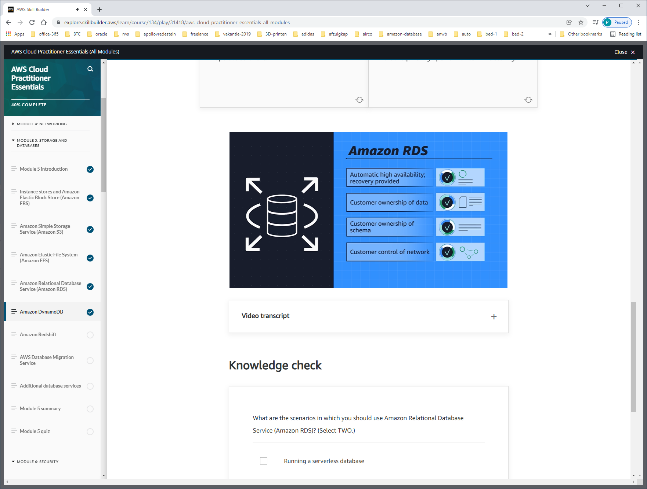

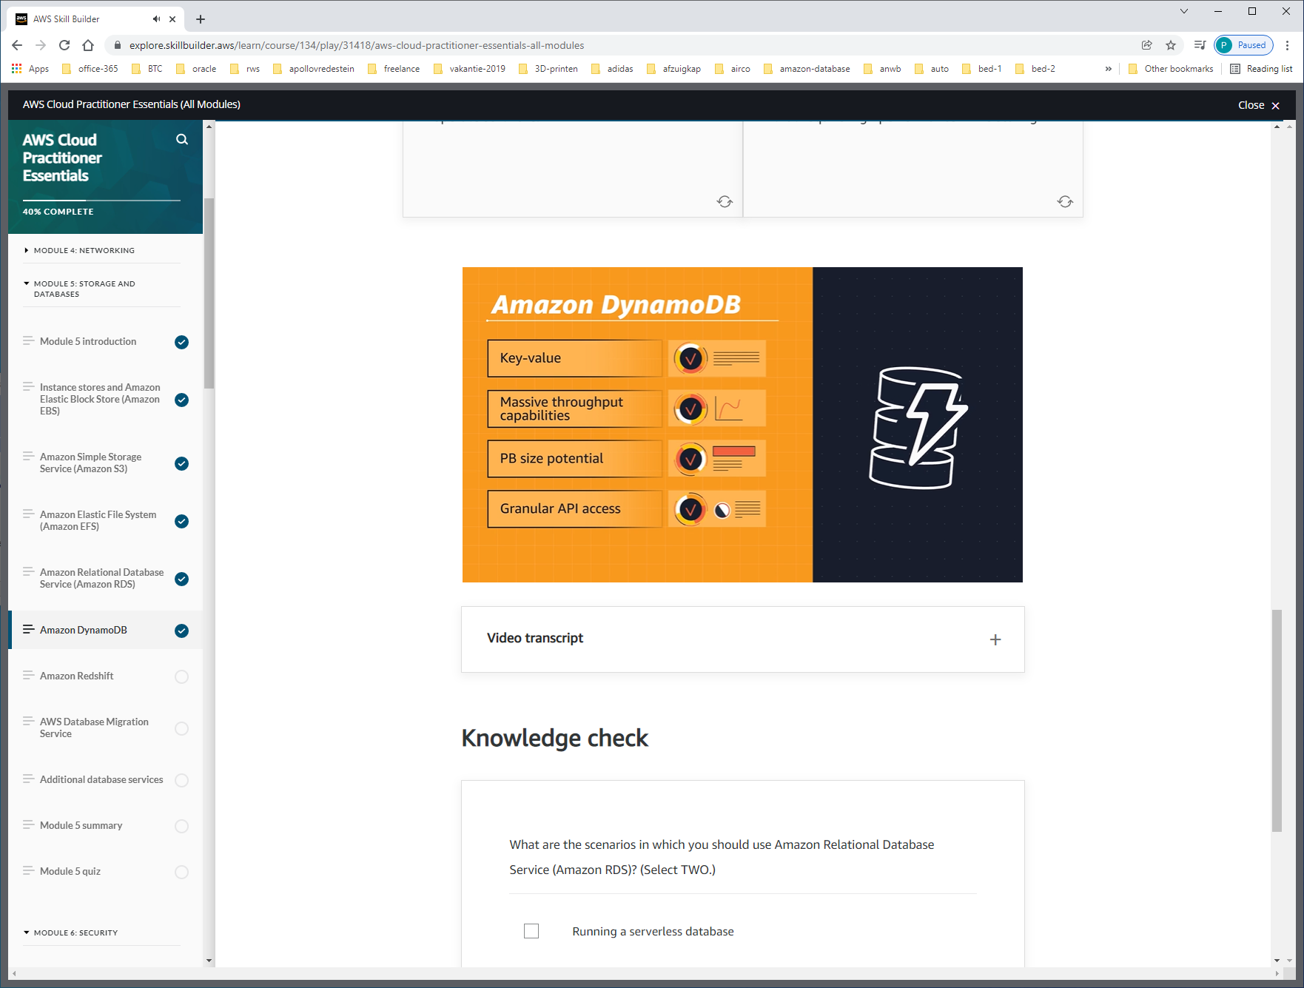

Use-cases:

sales-supply-chain-system for analytics: RDS  
anything else: DYNAMO-DB (single-table territory)

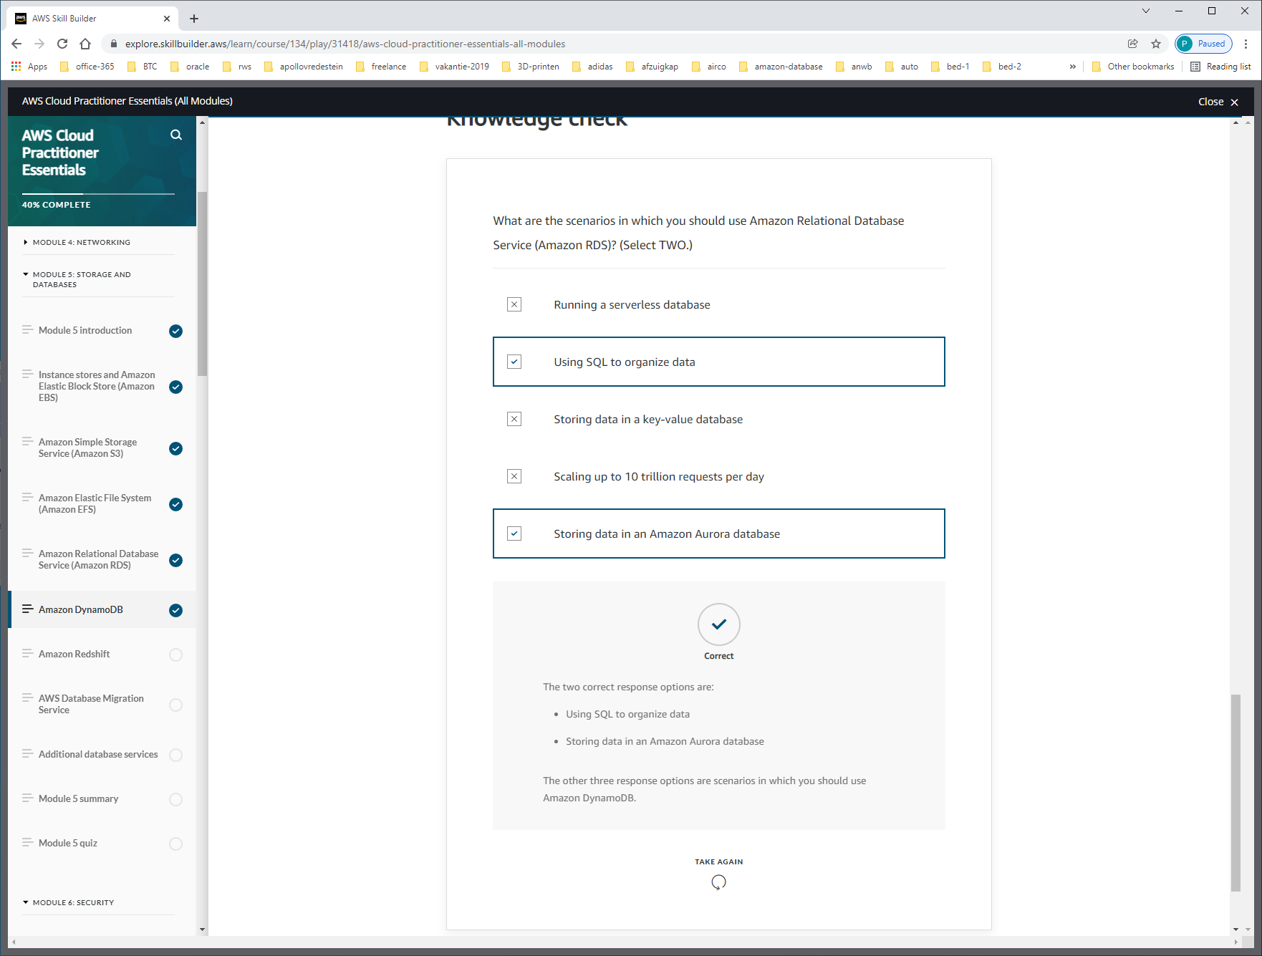

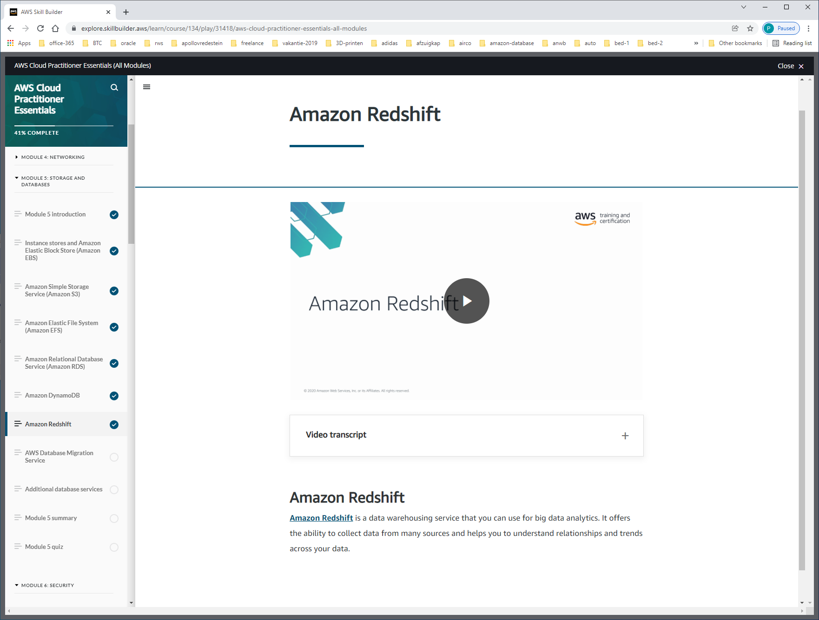

[**Amazon Redshift**](https://aws.amazon.com/redshift) is a data warehousing service that you can use for big data analytics. It offers the ability to collect data from many sources and helps you to understand relationships and trends across your data.

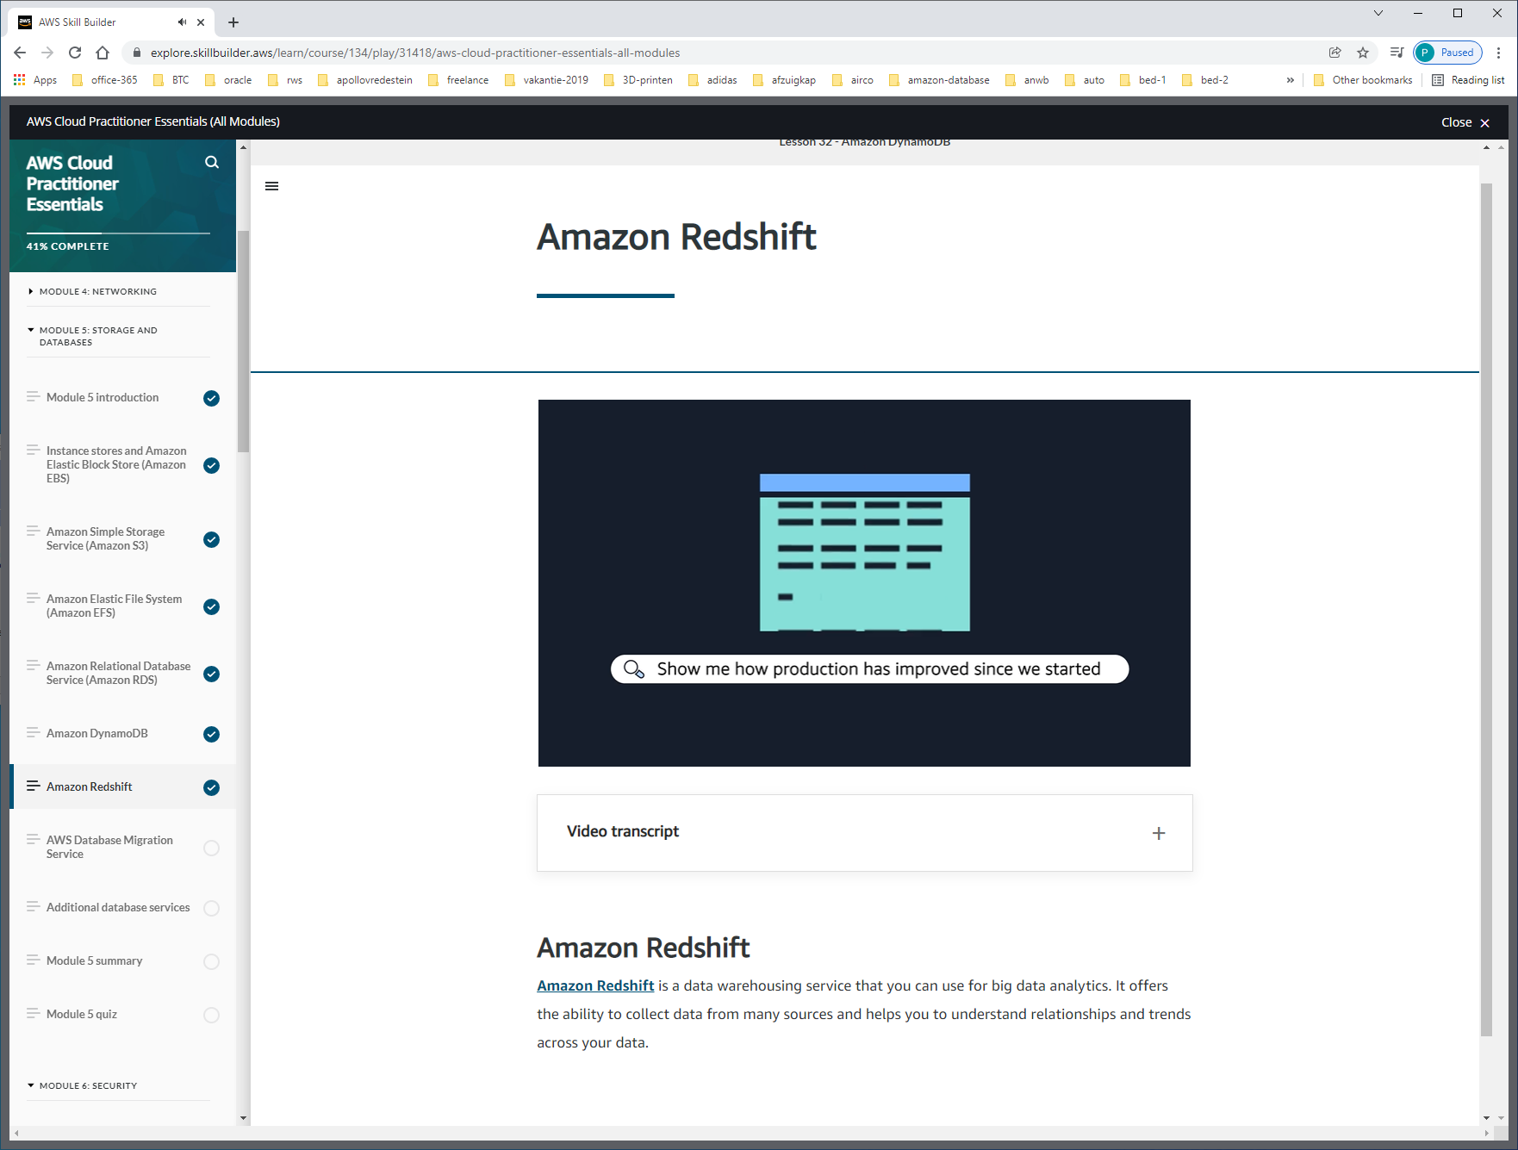

Volume kan een probleem vormen  
The variety of data can be a problem

Introducing Amazon Redshift. This is data warehousing as a service. It's massively scalable. Redshift nodes in multiple petabyte sizes is very common. In fact, in cooperation with Amazon Redshift Spectrum, you can directly run a single SQL query against exabytes of unstructured data running in data lakes.

Redshift uses a variety of innovations that allow you to achieve up to 10 times higher performance than traditional databases, when it comes to these kinds of business intelligence workloads.

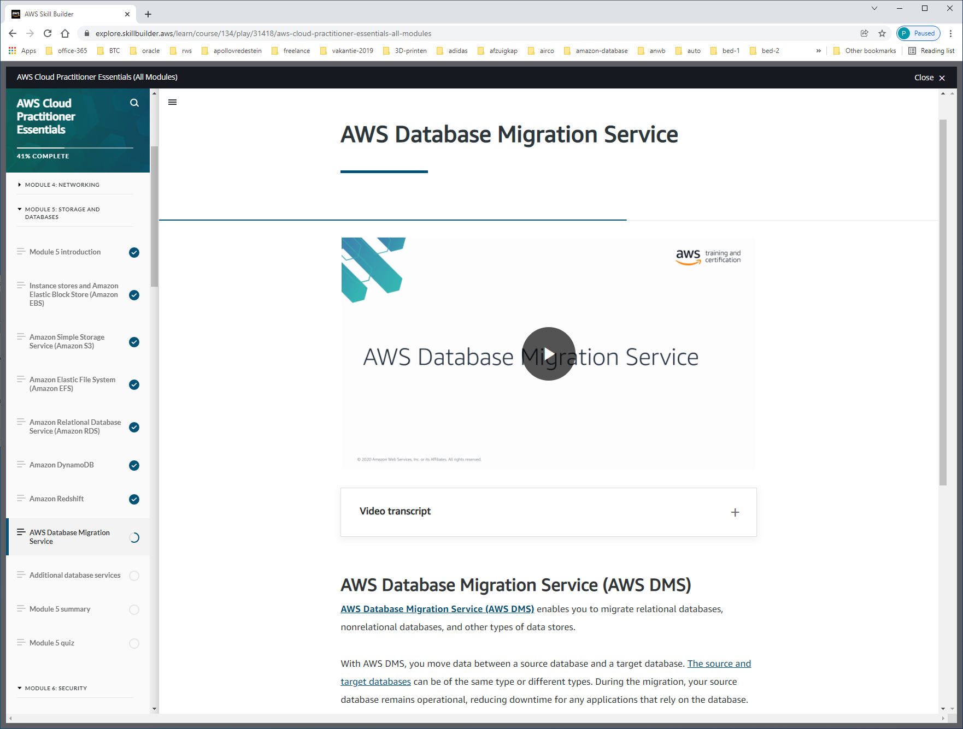

With AWS DMS, you move data between a source database and a target database. [The source and target databases](https://aws.amazon.com/dms/resources) can be of the same type or different types. During the migration, your source database remains operational, reducing downtime for any applications that rely on the database.

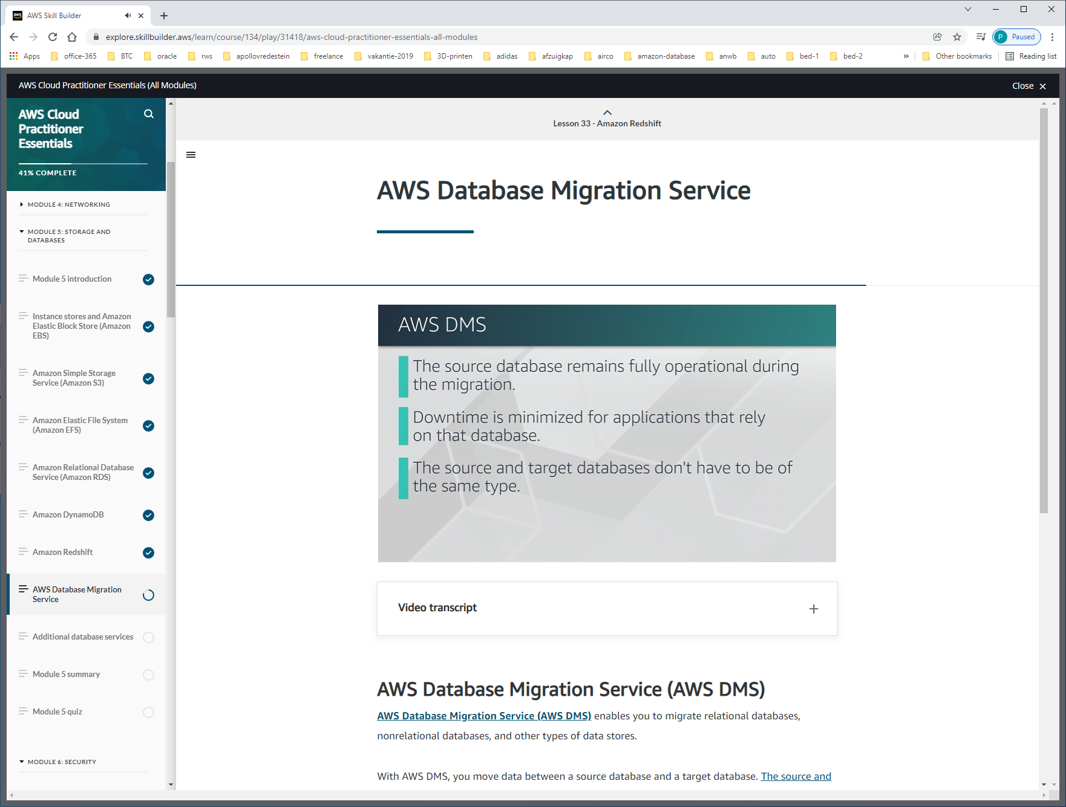

HOMOGENEOUS-DATABASE-MIGRATION (SOURCE + TARGET ARE SAME DB, mysql, sqlserver, oracle)

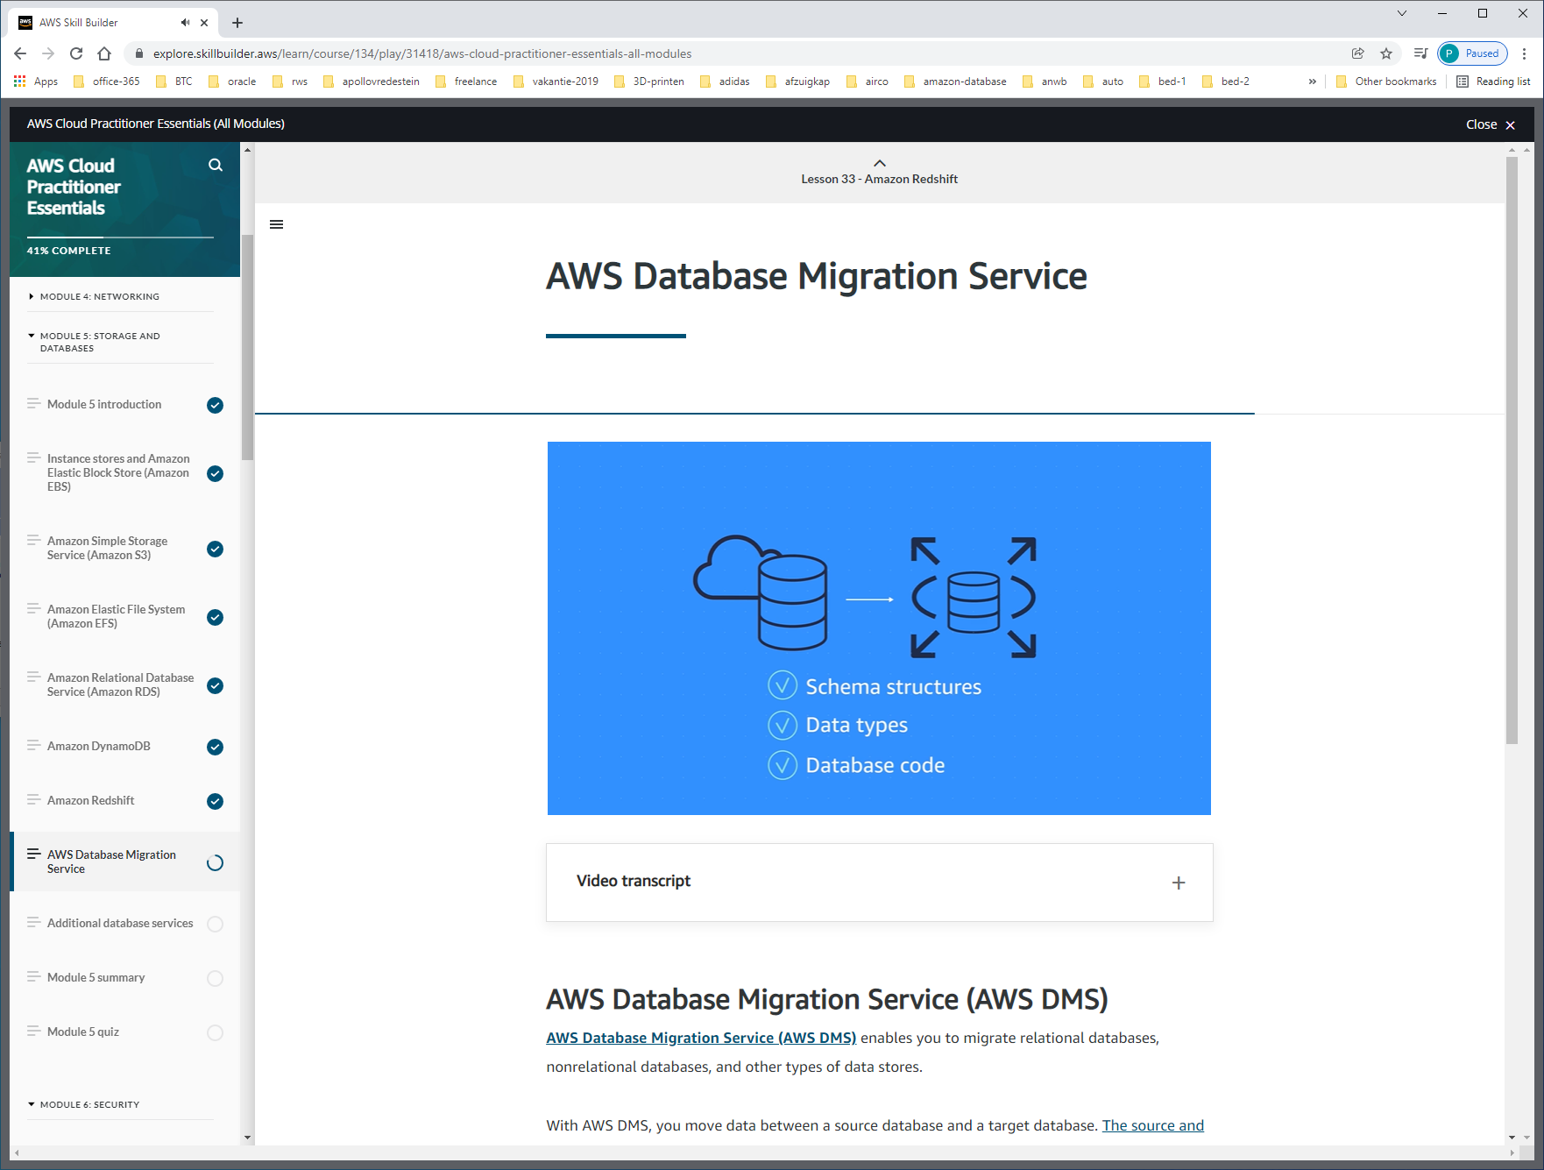

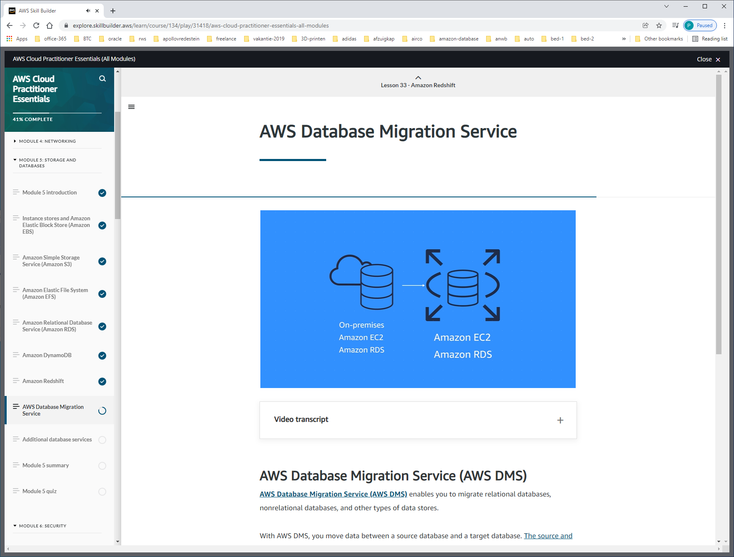

HETEROGENE DATABASES (source + target database different)

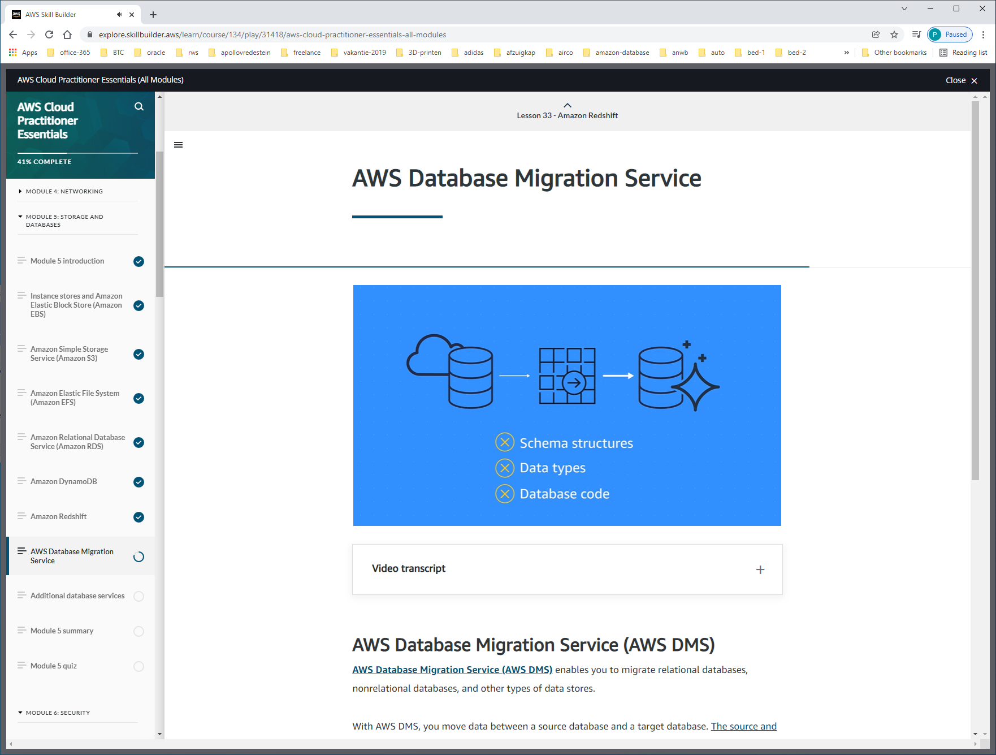

Omdat structuur anders is moeten we eerst migreren naar schema-convertion-tool, to match naar target-db.

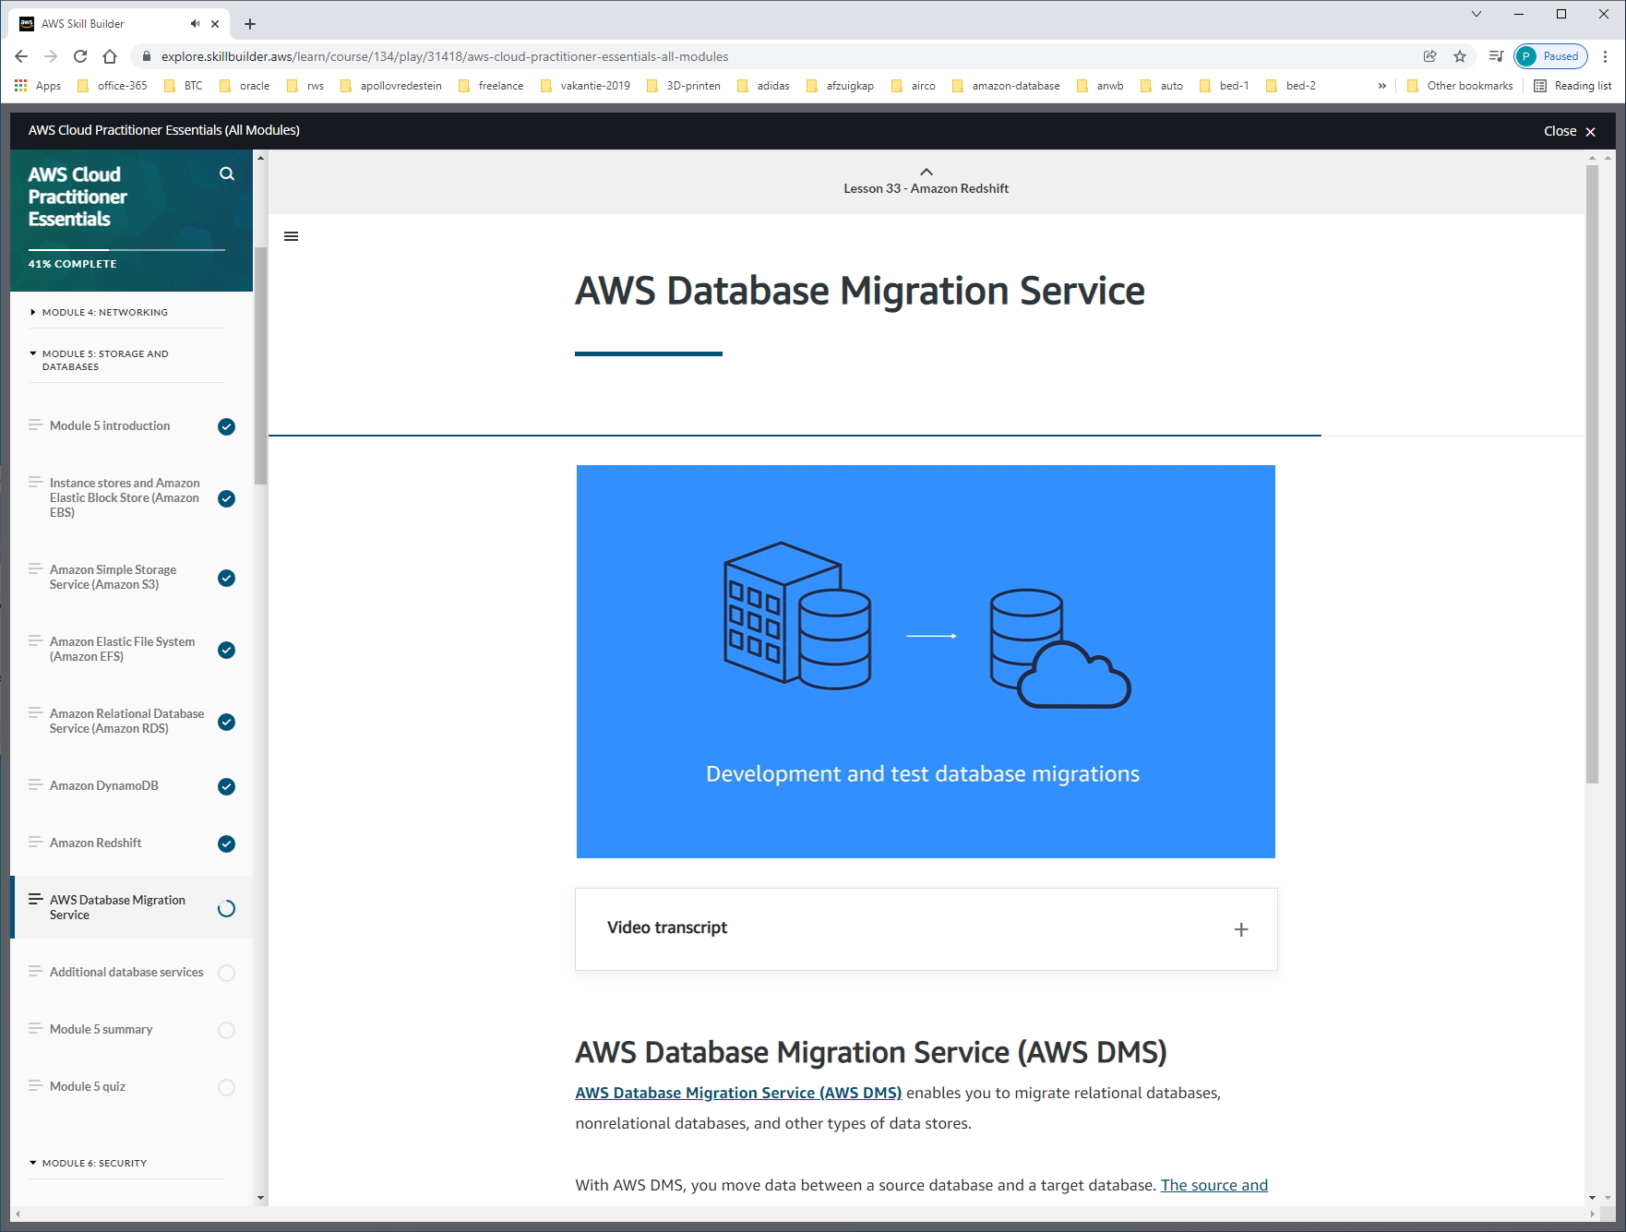

Met DMS kun je kopie maken van prod-omgeving naar test/dev-omgeving.

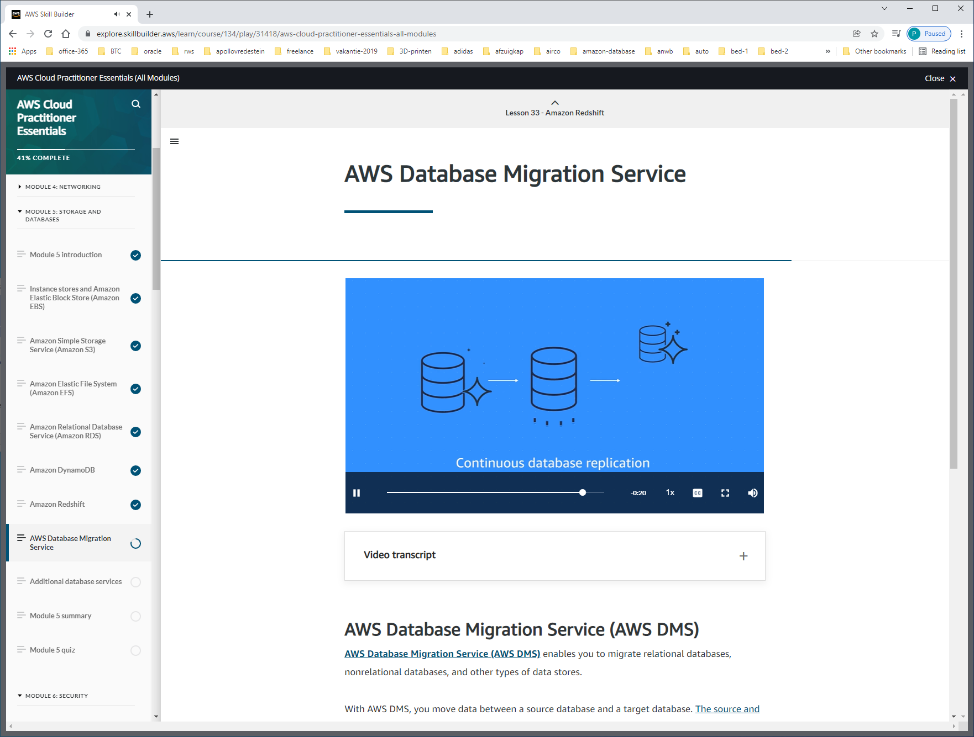

Of

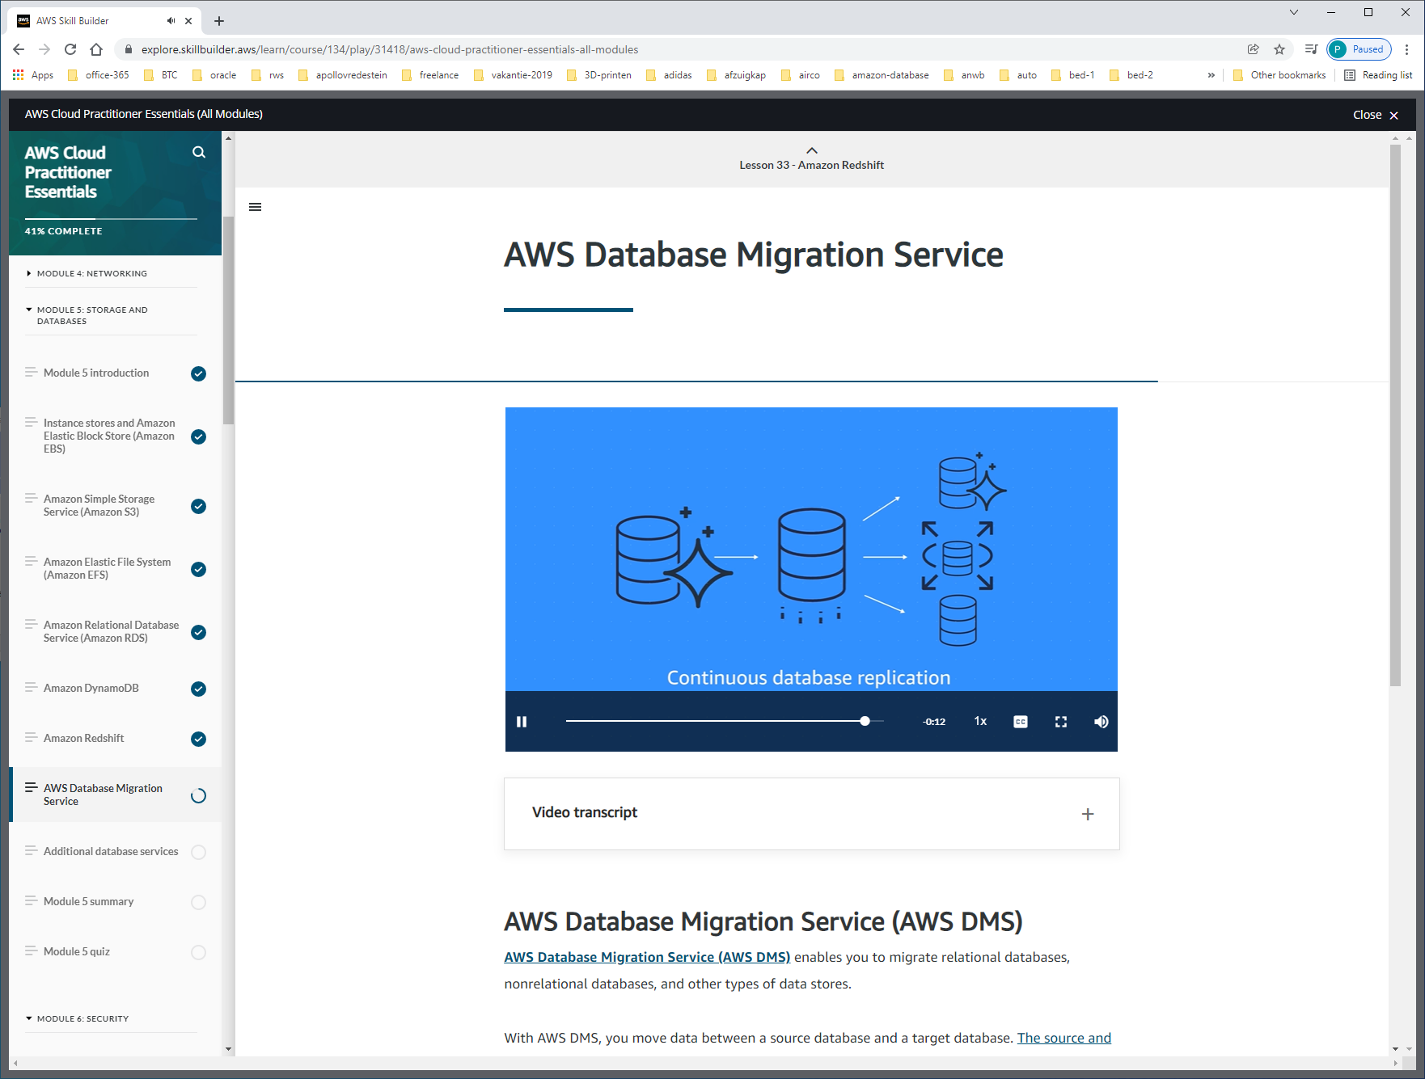

Voor disaster-recovery of performance

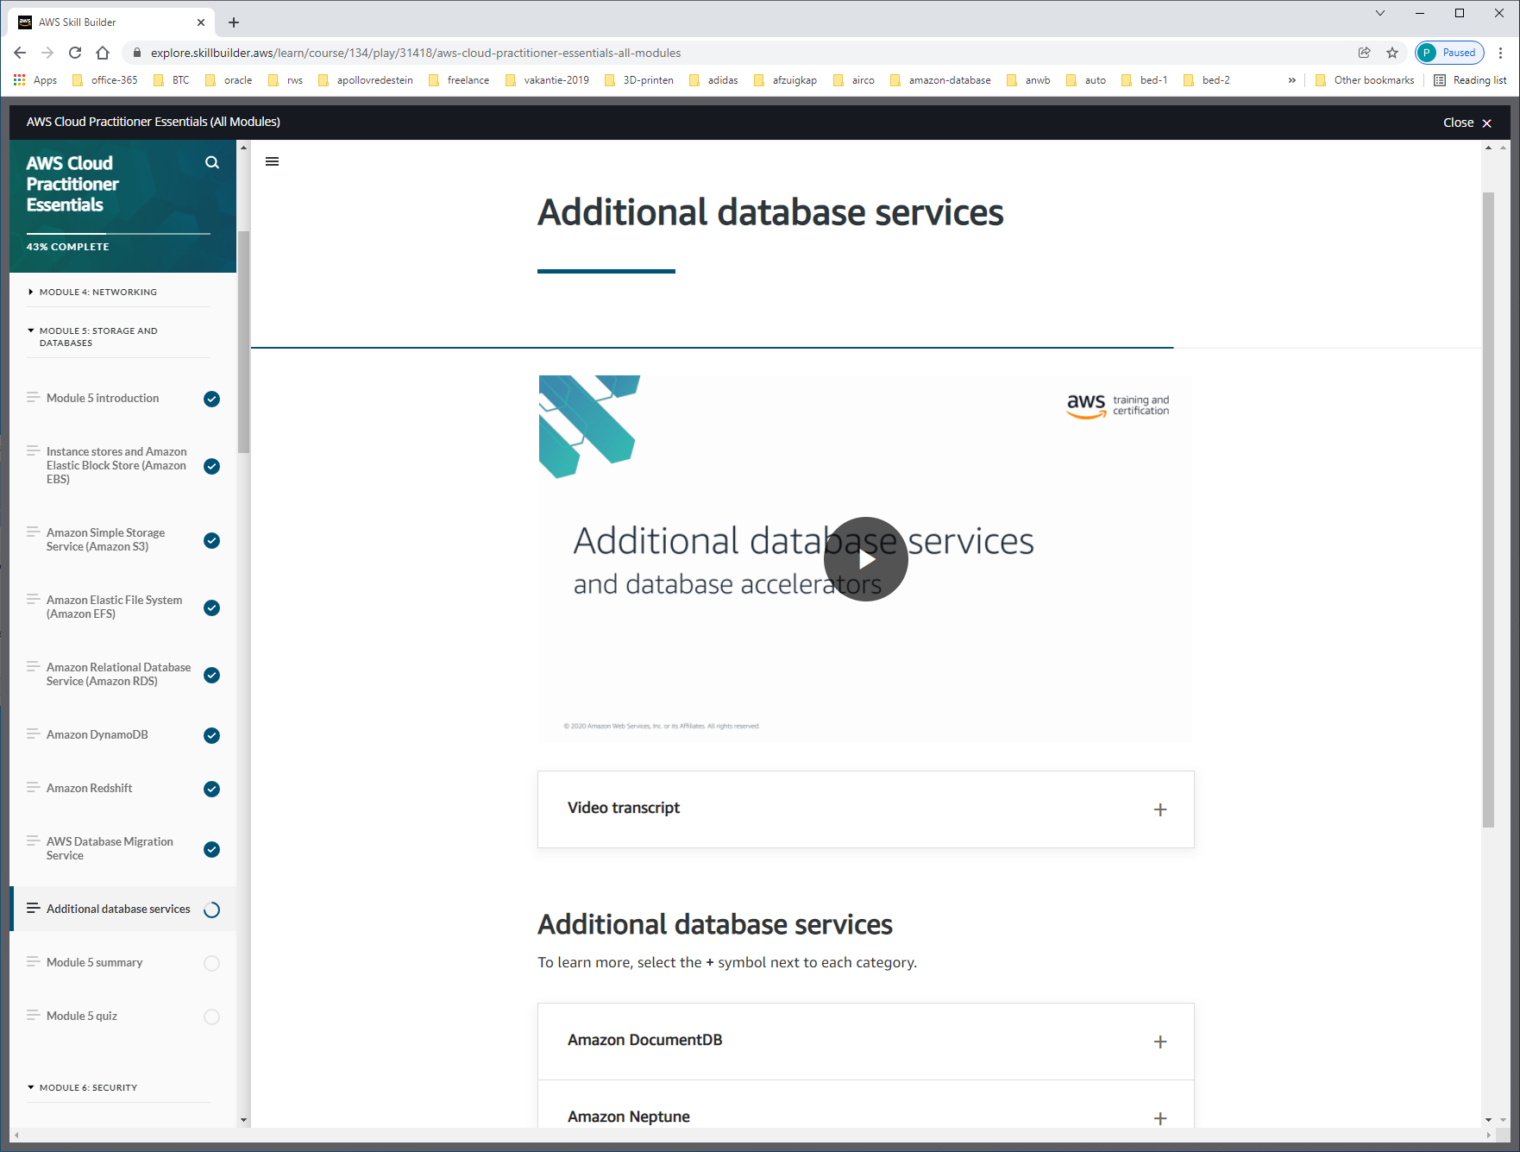

Choosing the right db + storage.

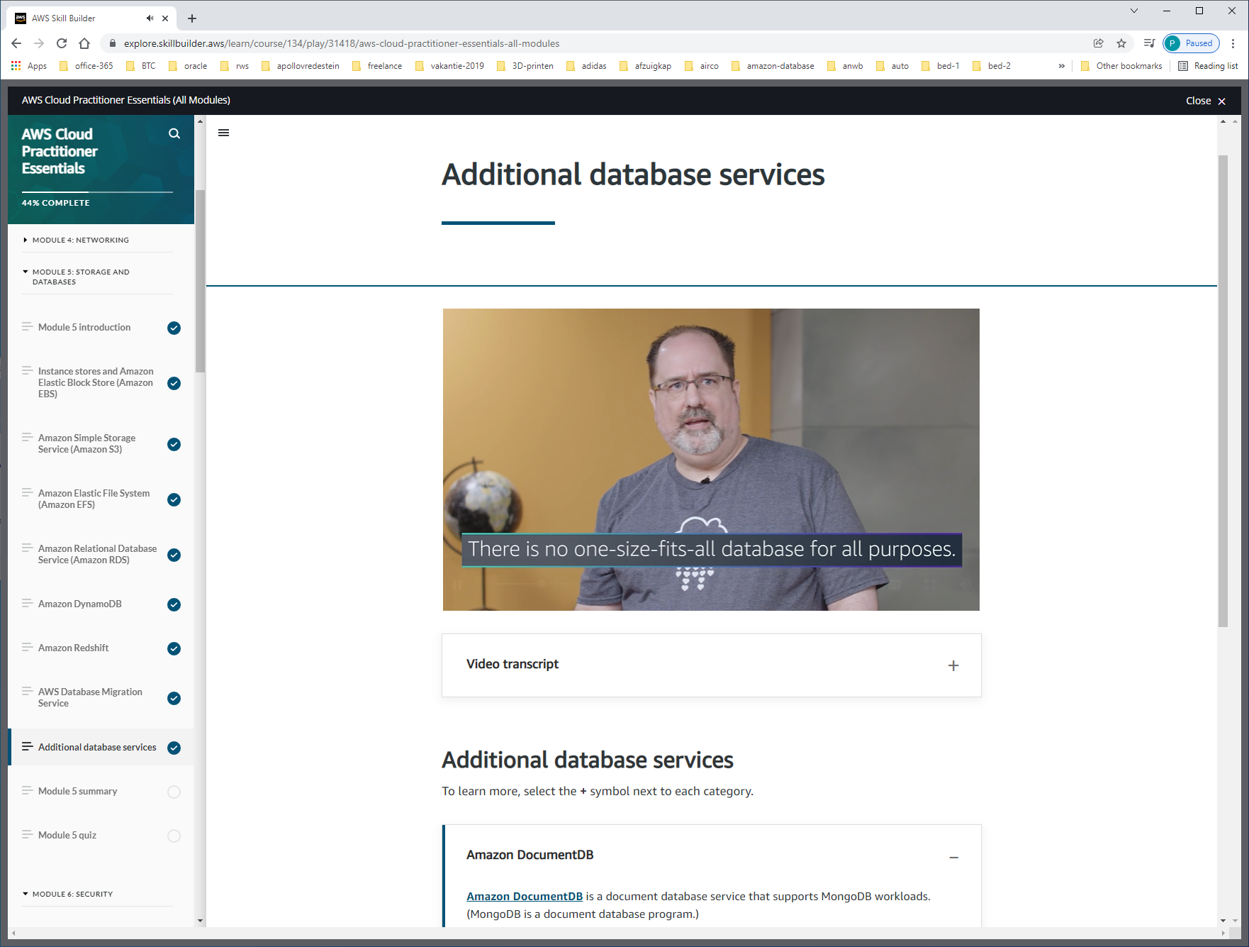

AMAZON DOCUMENT-DB (dms)

[**Amazon DocumentDB**](https://aws.amazon.com/documentdb) is a document database service that supports MongoDB workloads. (MongoDB is a document database program.)

AMAZON NEPTUNE (graph-db)

[**Amazon Neptune**](https://aws.amazon.com/neptune) is a graph database service.

You can use Amazon Neptune to build and run applications that work with highly connected datasets, such as recommendation engines, fraud detection, and knowledge graphs.

AMAZON QUANTUM LEDGER DATABASE (Amazon QLDB)

[**Amazon Quantum Ledger Database (Amazon QLDB)**](https://aws.amazon.com/qldb) is a ledger database service.

You can use Amazon QLDB to review a complete history of all the changes that have been made to your application data.

AMAZON MANAGED BLOCKCHAIN

[**Amazon Managed Blockchain**](https://aws.amazon.com/managed-blockchain) is a service that you can use to create and manage blockchain networks with open-source frameworks.

Blockchain is a distributed ledger system that lets multiple parties run transactions and share data without a central authority.

AMAZON ELASTICACHE

[**Amazon ElastiCache**](https://aws.amazon.com/elasticache) is a service that adds caching layers on top of your databases to help improve the read times of common requests. It supports two types of data stores: Redis and Memcached.

AMAZON DYNAMO-DB ACCELERATOR

[**Amazon DynamoDB Accelerator (DAX)**](https://aws.amazon.com/dynamodb/dax/) is an in-memory cache for DynamoDB.

It helps improve response times from single-digit milliseconds to microseconds.

TEST

